Bertha (Amedee) Poleto

February 10, 1918 – August 3, 2001

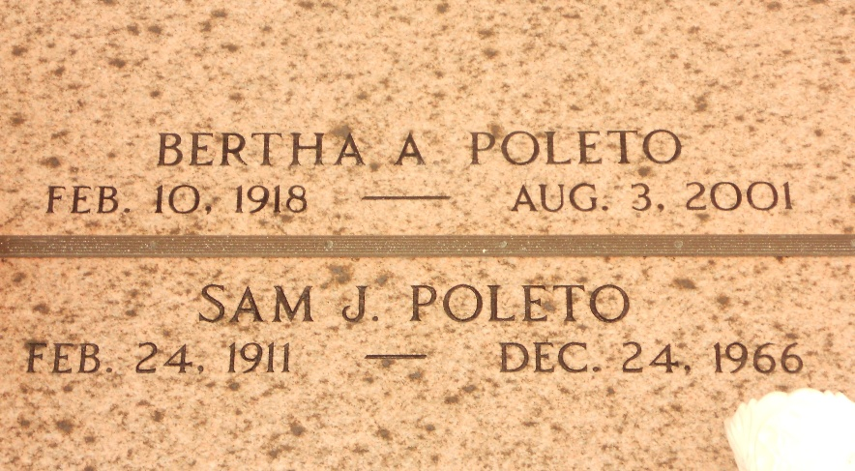

Photo by Team T-Lo

GARYVILLE - Bertha Amedee Poleto, 83, a native of Vacherie and resident of Garyville for 75 years, died Aug. 3.

She was the wife of the late Sam Joseph Poleto and mother of Judy Toups and Allen Poleto. She was the daughter of the late Sulpice and Lavinia Weber Amedee and sister of Sultana Rodrigue, Loranza Blank and the late Georgina Simon, Annette Simon, Yvette Waguespack, Fedilise Hymel, James Samuel and Norman Amedee. She is survived by six grandchildren and seven great-grandchildren.

Services were Aug. 7 at St. Hubert Catholic Church, Garyville, with interment at St. Peter Cemetery, Reserve.

L'Observateur, LaPlace, Louisiana

August 8, 2001