John Courtney Porteous III

August 2, 1939 – June 28, 2014

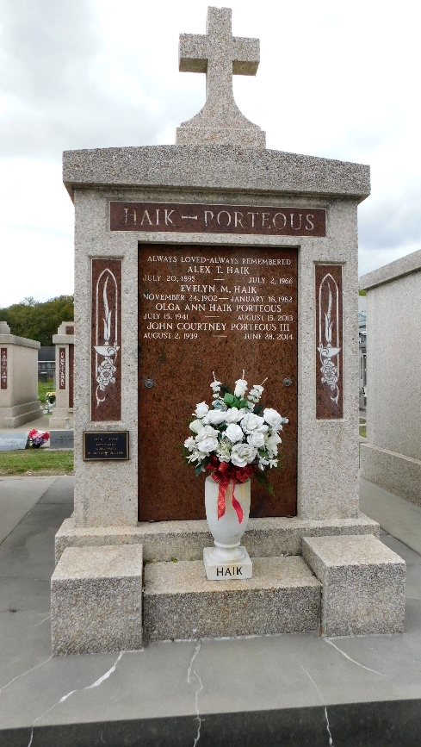 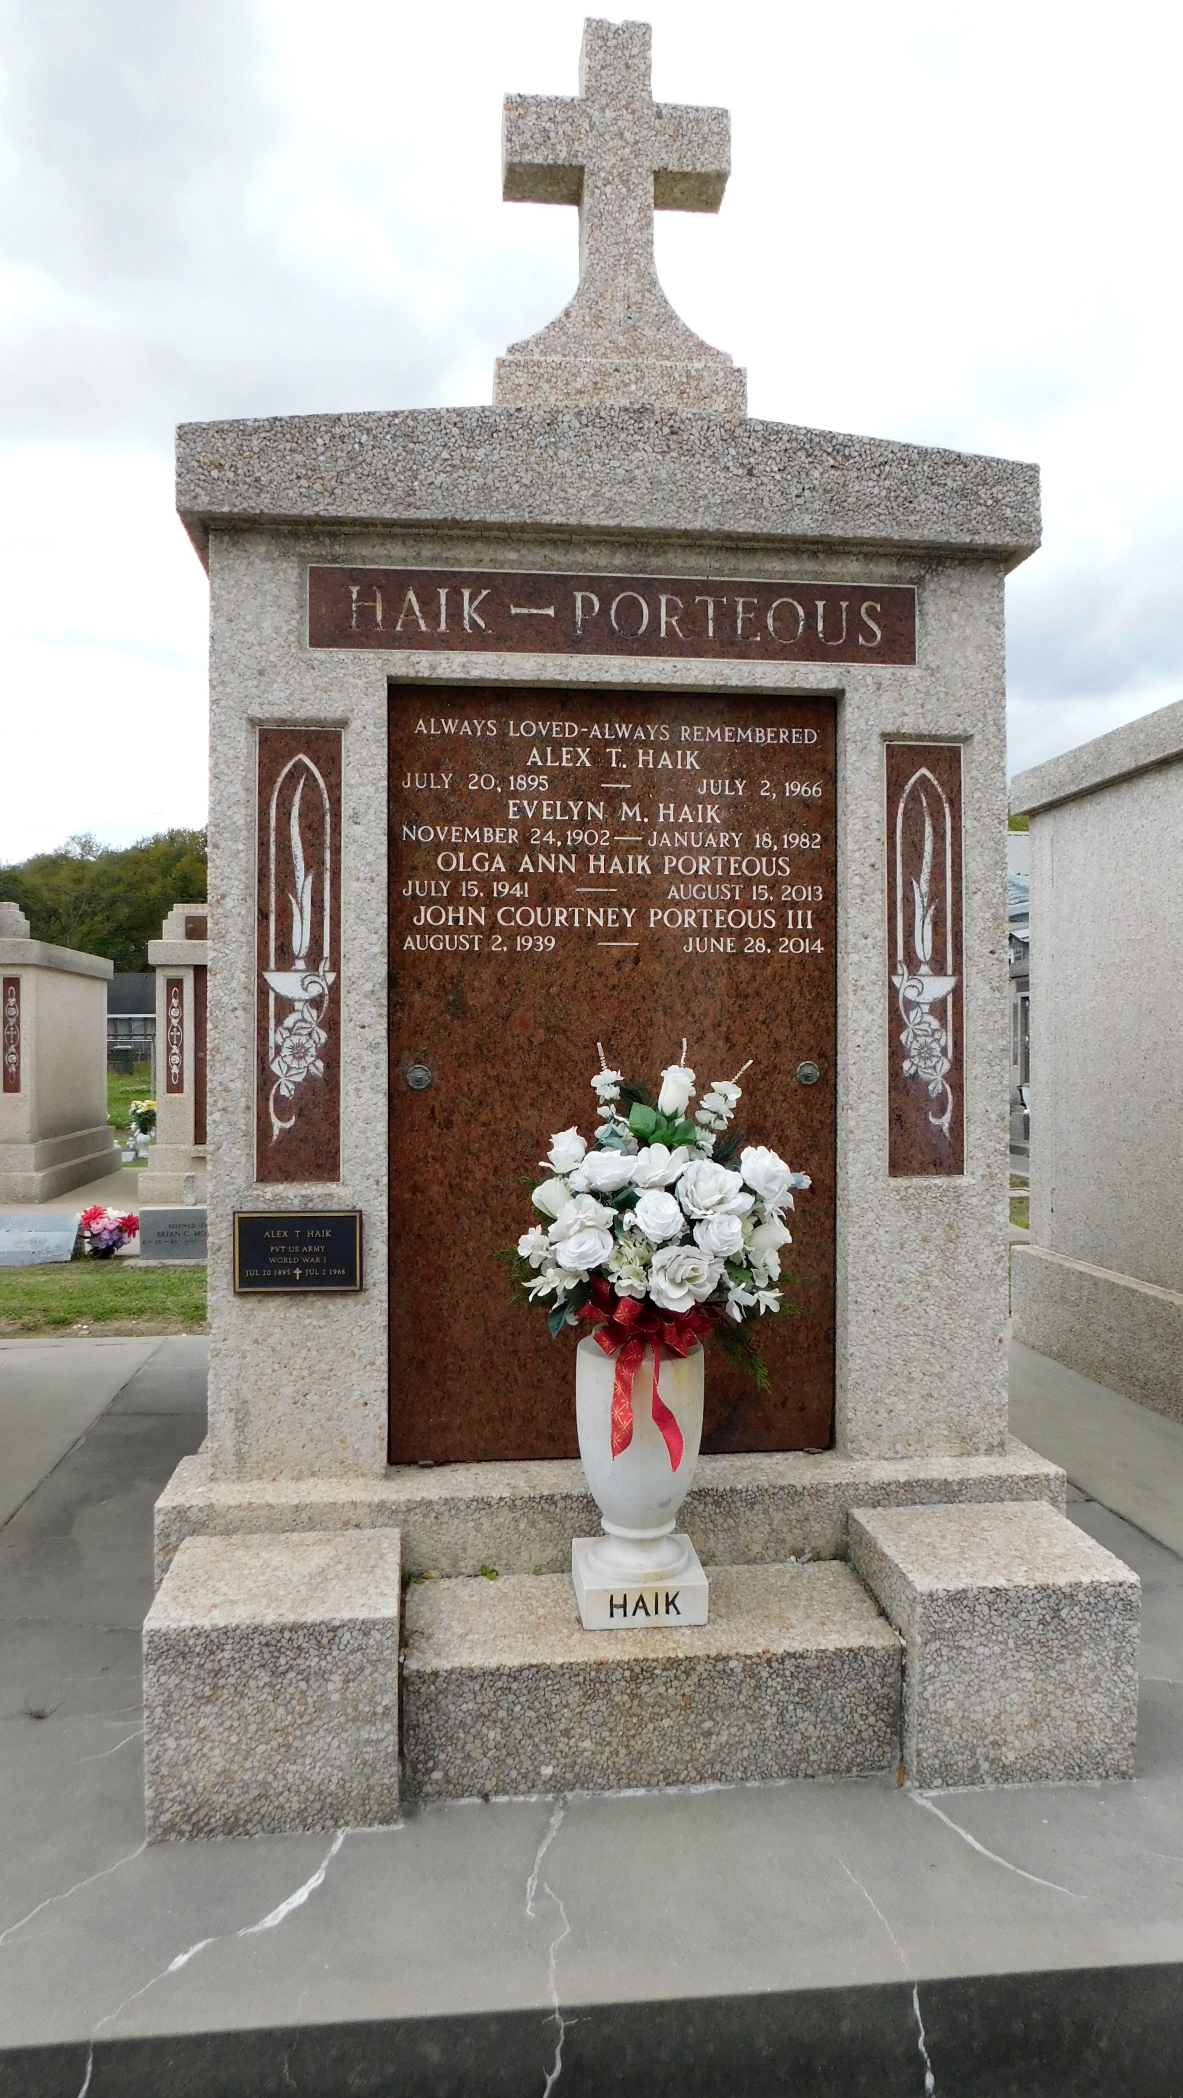

Photos by Mary Agnes Hammett

John Courtney Porteous, III entered into eternal rest on June 28, 2014 at the age 74 years.

Beloved husband of 49 years to the late Olga Ann Haik Porteous. Treasured father of Courtney Ann Porteous Millet (Leandre) & Susan Carol Porteous Campbell (John) of LaPlace. He took extreme pride in his 4 grandchildren, Leandre Michael Millet, Jr., Jeffrey Porteous Millet, John Royce Campbell, Jr., & Kelly Haik Campbell. Brother of Mary Ann Porteous Guidry, Patricia Porteous Johnson, & James Warren Porteous.

John joins his sister Beverly Porteous Zeringue in eternal rest along with his parents the late Mary & John Courtney Porteous of Lutcher. John proudly served in the Army National Guard of Louisiana.

Because of his generous heart of gold, he never refused to help any family member or friend in need. He was a loving & devoted husband, father, grandfather, uncle, & brother & a long time member of St. Peter Catholic Church.

A Funeral Mass will be held on Tues, July 1, 2014 at St. Peter Catholic Church, Reserve, LA at 3 pm. Visitation will begin at 1-3 pm at St. Peter Catholic Church. Burial will be in St. Peter Cemetery in Reserve, La. Arrangements by Millet-Guidry Funeral Home.

The Times-Picayune / The New Orleans Advocate, Louisiana

30 Jun - 2 Jul, 2014