Ruby (Leche) Porter
December 20, 1929 – September 4, 2017

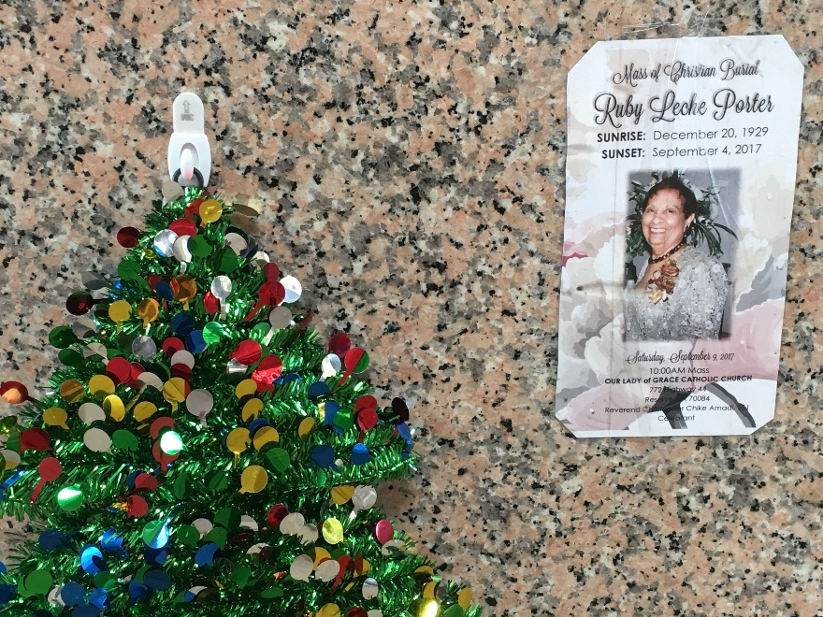
Photo by Team T-Lo

Ruby Porter on Monday, September 4, 2017 at her home in LaPlace, LA. Daughter of the late Felicia Madere and Nicholas Leche. Mother of Louis Reginald Porter (Patsy) and Huey Joseph Porter (Barbara). Sister of Claudia Farlough (Cleveland), the late Lorraine Wheeler, Hubert, Clyde, Alvin, Walter and Leroy Leche. Sister in law of Allen Wheeler. Also survived by 10 grandchildren, 24 great grandchildren and a host of nieces, nephews, cousins, other relatives and friends. Age 87 years. A native of Reserve, LA and a resident of LaPlace, LA.
Relatives and friends of the family, also priest and parishioners of Our Lady of Grace Catholic Church and all neighboring churches are invited to attend the Funeral Mass at Our Lady of Grace Catholic Church, 772 Hwy 44 (River Road), Reserve, LA on Saturday, September 9, 2017 at 10:00 AM. Father Christopher Amadi, Celebrant. Interment St Peter Cemetery, Reserve, LA. Visitation at the above named church from 8:15 AM until Mass time. Rosary at 9:15 AM SERVICED BY ROBOTTOM

The Times-Picayune, New Orleans, Louisiana
Sep. 5 to Sep. 8, 2017

