James Nealon Prudhomme Sr.

July 25, 1904 – January 6, 1976

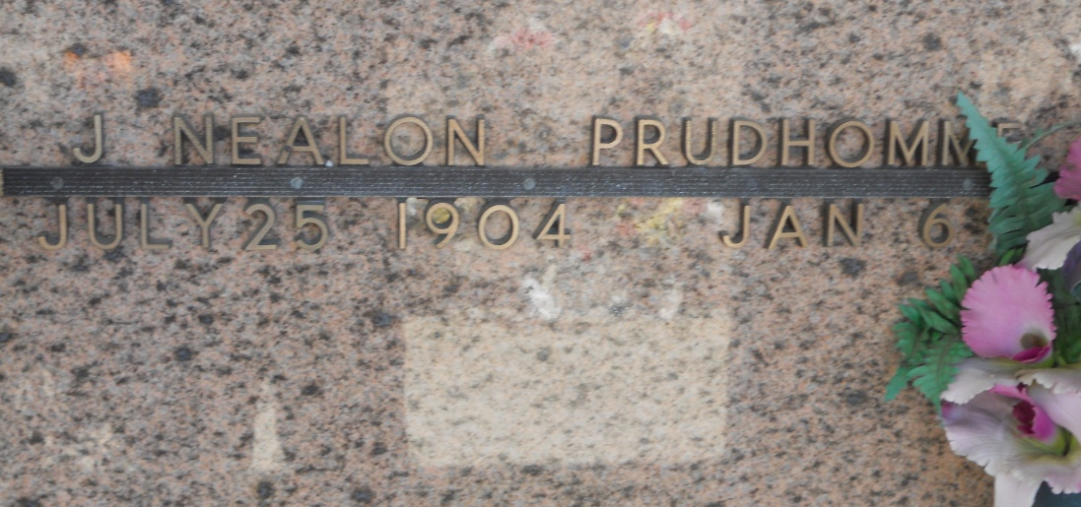

Photo by Team T-Lo

Age 71 years, a native of Campti, Louisiana, and a resident of Laplace, Louisiana, for 55 years.

Husband of the late Palmyre Brady, father of Warren and Richard Prudhomme and Nealon Prudhomme Jr.

He was the son of Mrs. Jessie McKnight Prudhomme of Campti.

Services were Thursday 8 Jan 1876 at St Joan of Arc Church, Laplace, with interment in St Peter Cemetery, Reserve, Louisiana.

The Times-Picayune, New Orleans, Louisiana

January 8, 1976