Palmyre (Brady) Prudhomme

June 9, 1903 – September 11, 1961

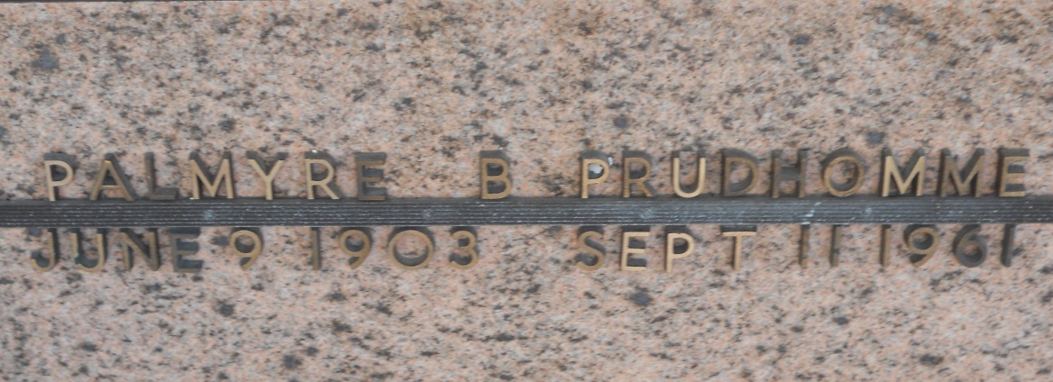

Photo by Team T-Lo

Palmyre Brady Prudhomme, a native and resident of Laplace, Louisiana, died in New Orleans on Monday, 11 Sep 1961 at 5:00 p.m. at age 58 years.

She was the wife of Nealon J Prudhomme and the mother of Warren, Richard and Nealon Prudhomme Jr. She was the sister of Yvonne, Peter, Theodore and Anthony Brady and the niece of Rosa Montz. Also survived by 15 grandchildren.

Services were Wednesday 13 Sep 1961 at St Joan of Arc Church, Laplace, with interment in St Peter Cemetery, Reserve, Louisiana.

The Times-Picayune, New Orleans, Louisiana

September 12, 1961