Suzanne Marie (French) Pruitt
September 25, 1964 - April 22, 2026

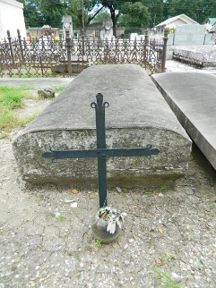

Suzanne Marie French Pruitt was called to her eternal home on Wednesday, April 22, 2026, at the age of 61.
Suzanne, a resident of Douglasville, Georgia, and a native of LaPlace, Louisiana, was born on September 25, 1964, to Albert French, Jr. and Olivia Porche’ French.
She leaves to cherish her memories, her husband, Anthony L. Pruitt; stepdaughter, Jadoeci Pruitt; adopted son, Attorney Jarrette J. Tuircuit; mother and father-in-law, Bobby and Yolanda Pruitt; sister, Evelyn T. French; sister-in-law, Andreana Pruitt (Shenise); nephews, Grant Pierre, Jr. (Catherine), Mark Pierre (Phyllicia), Donavon Pierre, Ashton Pierre (Stacy), Jeremy Pierre, Lance French, Sr. (Lakeria), Alonzo Patterson, Sr., Kevaughn Marshall, Sr., and Alvin Zeringue, III; aunt-in-law, Patricia Simpson and maternal aunt and uncle, D. Ann Porche’ and Morris Porche’, Jr. A host of great nieces and nephews, devoted friends, other relatives, and dear and devoted friends.
Suzanne is preceded in death by her parents, Albert French, Jr. and Olivia Porche’ French; sisters, Anita K. Pierre and Alanna Y. French; grandparents, Evelyn and Morris Porche’, Sr. and Claudia and Albert French, Sr.; and godparents, Leona Roberts and Matthew “Fats” Houston.
Suzanne’s bright smile, infectious laughter, piercing personality, and unwavering love and support will be immensely missed by everyone whose lives she touched.
Friends and family, colleagues, parishioners of Our Lady of Grace Roman Catholic Church and Our Lady of Lourdes Catholic Church of Atlanta, Georgia, and neighbors of Suzanne Marie French Pruitt are all invited to attend a Mass of Christian Burial at 11:00am on Friday, May 1, 2026, at Our Lady of Grace Roman Catholic Church, 772 Highway 44, Reserve, Louisiana 70084. Visitation will begin at 8:15a.m. followed by the Holy Rosary and Mass beginning at 11:00 a.m. Final resting place at St. Peter’s Catholic Cemetery, 143 W. 7th Street; Reserve, Louisiana 70084.

Patrick H. Sanders Funeral Home, LLC., LaPlace, Louisiana

