Susan (Millet) Radeaux
September 13, 1946 – December 27, 2019

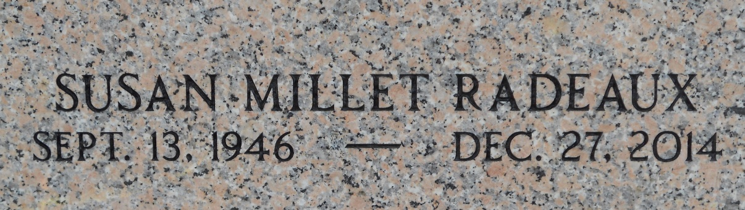
Photo by Team T-Lo

Susan Millet Badeaux passed away at her residence on Saturday, December 27, 2014 at the age of 67. She was born in New Orleans and was a lifelong resident of Montz. She was a registered nurse and retired from the S. E. LA War Veterans Home.
Beloved wife of Bruce Badeaux. Loving mother of Billy, Patrick, Tracy and Larry Barbay and Cherie and Beau Badeaux. Daughter of the late Betty Ward and Sidney Millet, Jr. Sister of Carolyn Maples and the late John Millet. She is also survived by many grandchildren.
Relatives and friends are invited to attend the Funeral Mass at St. Peter Catholic Church, 1550 Hwy 44, Reserve on Wednesday, December 31, 2014 at 11:00 a.m. Visitation will begin in church at 9:00 a.m. Interment in St. Peter Cemetery.

Millet-Guidry Funeral Home, LaPlace, Louisiana

