Erwin Andrew Ramirez
April 6, 1915 – May 3, 2004

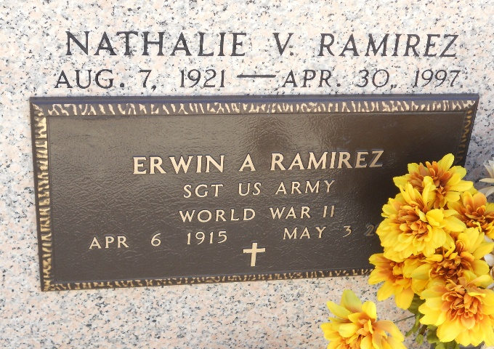
Photo by Team T-Lo

Erwin A. Ramirez on Monday May 3, 2004 at 6:35 a.m.
Beloved husband of the late Nathalie (Nat) Vicknair Ramirez. Father of Mary Ellen Leingang, Jeanette Cashio, David Ramirez, Carol Wiedemann and Alice Pruitt. Son of the late Adolph and Louise Ramirez. Brother of the late Adolph Ramirez. Cousin of Jake Newton. Also survived by 12 grandchildren and 4 great-grandchildren. Age 89. A native of DeRidder, LA. Former resident of Garyville and a resident of Harahan for the past 34 years.
Relatives and friends of the family also members of VFW Post 8167, Garyville and Shell Oil Employees are invited to attend services. Visitation at Millet-Guidry Funeral Home, 2806 W. Airline Hwy, Laplace on Wednesday May 5, 2004 from 9am-11am, followed by religious services in the Funeral Home Chapel at 11 a.m. Burial in St. Peter Cemetery, Reserve.
The Times-Picayune, New Orleans, Louisiana
May 4 to May 5, 2004

