Nathalie Mildred (Vicknair) Ramirez
August 7, 1921 – April 30, 1997

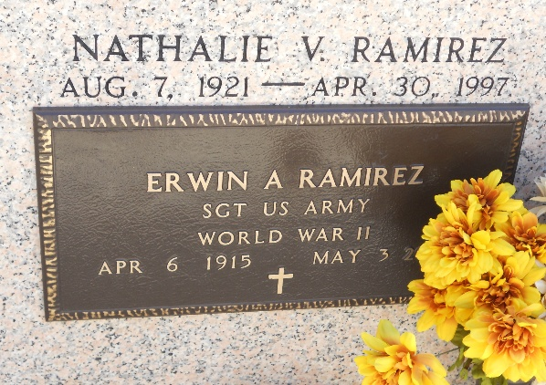
Photo by Team T-Lo

Nathalie Mildred VICKNAIR
¹Social Security Application and Claims Index, 1936-2007 (Ancestry.com). "Name: Nathalie Mildred Vicknair [Nathalie Vicknair Ramirez]
SSN: xxx
Gender: Female; Race: White
Birth Date: 7 Aug 1921; Birth Place: Garyville, Louisiana
Death Date: 30 Apr 1997
Father: Wilfred Vicknair; Mother: Aline Bourgeois
Type of Claim: Original SSN.
Notes: Jun 1939: Name listed as NATHALIE MILDRED VICKNAIR; Mar 1952: Name listed as NATHALIE VICKNAIR RAMIREZ; 14 May 1997: Name listed as NATHALIE V RAMIREZ."

²Jay M Schexnaydre, St. Peter Catholic Church Cemetery (LES VOYAGEURS), Vol XXIV, No 1, Mar 2003, p 5.
³Social Security Death Index.
⁴Obituary, L'OBSERVATEUR, St John the Baptist Parish, LA, Public Library, Laplace, LA.
Researched by Dwayne Montz

