John Aloysius Rauch Jr.
October 5, 1941 – October 13, 2019

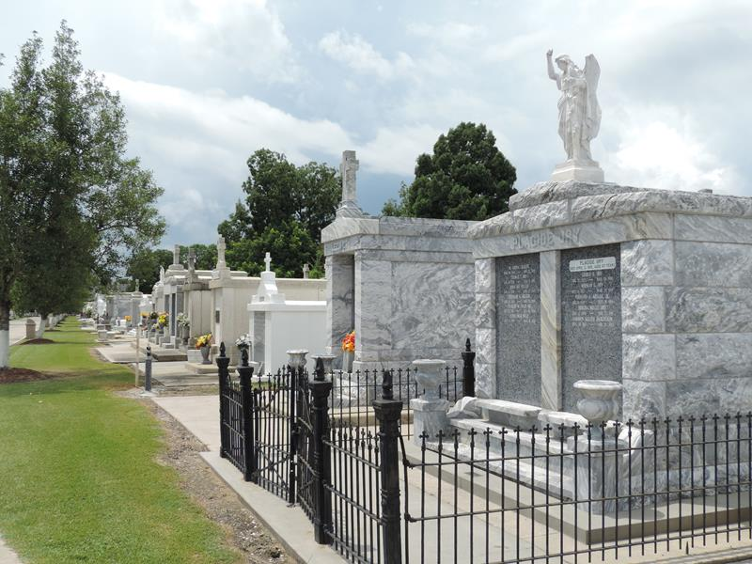

John Aloysius Rauch, Jr. passed away on Sunday, October 13, 2019, at the age of 78 at Ochsner Kenner in the care of Hospice Compassus. Born October 5, 1941, in Opelousas, Louisiana. He was a resident of Laplace, Louisiana.
Beloved husband of Irene Marie Stumpf Rauch. Son of the late Thelda and John Rauch, Sr. Father of Jeannell Marie Ritter (James), John William Rauch, Clay Andrew Rauch, Clare Elizabeth Drexel (Brent), and David Bernard Rauch (Stephanie). Brother of Julie Rauch-States, Gerard Rauch (Patricia), Patrick Rauch and the late Bernard Rauch. Grandfather of Matthew James, Sarah Elizabeth, Thomas John and Jacob Aaron Ritter, Cassandra Gemma Kidder (Forrest), Corrin Hannah, Caylee Mary and Brayden Joseph Drexel, William David, Pierre Joseph and Beaux Michael Rauch. Great Grandfather of Baby Kidder.
John served in the United States Navy from August 1961 to August 1965. Retired from Delta Airlines. Member of the Knights of Columbus at Ascension of Our Lord. Awarded the St. Louis Medallion from the Archdiocese of New Orleans. He was a master at fishing, cooking, and gardening. He was loved and will be sadly missed by all who knew him.
Relatives and friends are invited to attend the Funeral Mass at Ascension of Our Lord Catholic Church at 1900 Greenwood Dr. LaPlace, Louisiana, on Thursday, October 17, 2019 at 11:30 a.m. Visitation at the Church from 9:30 a.m. to 11:30 a.m. Interment in St. Peter Cemetery, Reserve.
In lieu of flowers, the family has requested donations be made in his memory to the Saltillo Mexico Mission through Ascension of Our Lord Church or Masses. Arrangements made by Millet-Guidry Funeral Home.

The Times-Picayune, New Orleans, Louisiana
Oct. 15 to Oct. 17, 2019

