Donald J. Rebstock Sr.
Abt. 1932 - September 19, 2019

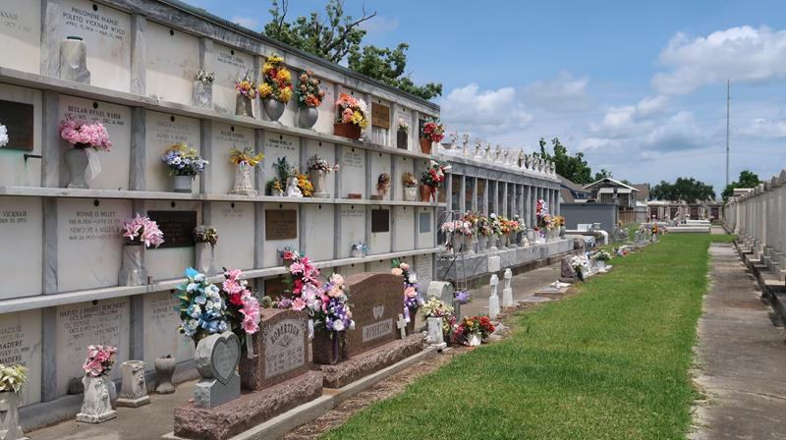

Donald J. Rebstock, Sr. passed away peacefully at his residence on Thursday, September 19, 2019 at the age of 87. He was a native of Golden Meadow, LA and a resident of LaPlace since 1968. Beloved husband of the late Margaret Reiley Rebstock. Father of Russel Rebstock (Terrie), Daniel Rebstock, Sr. (Jennifer), Shannon Brayard (Robert), Donald J. Rebstock, Jr. and Daren Rebstock (the late Danielle). Son of the late Florence Terrebonne Rebstock and Rosulas Rebstock. Brother of Robert ‘Bob’ Rebstock (Lou), Brenda Esponge (Robertson) and Rosulas ‘Reb’ Rebstock (Johnine). Also survived by 11 grandchildren, 4 great-grandchildren and many nieces and nephews.
Mr. Rebstock proudly served our country in the U.S. Navy during the Korean Conflict on the U.S.S. Boxer. After retiring from the Army Corps of Engineers, he went on to work for the University of New Orleans. While at UNO he founded and was President of S.A.T.E (Students Awareness Toward Education). His great temperament, humor and witness will be missed by all who knew him.
Relatives and friends are invited to attend the Funeral Service at Millet-Guidry Funeral Home, 2806 W. Airline Hwy., LaPlace on Tuesday, September 24, 2019 at 11:00 a.m. Visitation from 9:00 a.m. until 11:00 a.m. Interment in St. Peter Cemetery, Reserve.

Millet-Guidry Funeral Home, LaPlace, Louisiana
September 21, 2019

