Marjorie Ann (Plaisance) Redding
July 13, 1926 – June 1, 2017

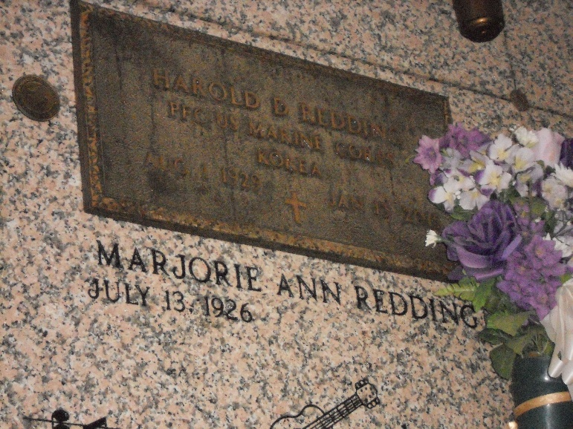
Photo by Team T-Lo

Marjorie Plaisance Redding passed away peacefully in the early morning hours of Thursday, June 01, 2017 at the age of 90 at her home in Jayess, MS where she had lived with her daughter, Fay Mitchell for the past 3 years. She was born on July 13, 1926 in Reserve, LA.
Ms. Redding was a long time resident of Houston, TX, where she retired at the age of 55 from Hill & Webb Laboratory Associates. She and her late husband, Harold Redding moved to Florida where they enjoyed many years of RV living and lots of fishing.
But the real love of her life was singing Country Music. She sang for many years on various stages here in the South. Some of her best times was just singing on the back porch with her children.
She was married to her late husband Harold D. Redding for over 40 years. She is survived by 6 children, Henry J. Kinler, wife Loretta; Margie LeBlanc, husband Paul; Terry L. Kinler, wife Shirley; Kay Stein, husband Norwood “Co”; Fay Mitchell, late husband James and Mark Crane, wife Tonna. She is survived by numerous grandchildren, great grandchildren and great-great grandchildren nieces, and nephews.
She is survived by sister, Juanita Breaud and brother Albert “A.J.” Plaisance. Marjorie was preceded in death by her former husband, Henry Kinler, Sr., Mother, Hilda Barbier Plaisance, Father, Albert J. Plaisance Sr., brother, Curtis J. Plaisance and sister, Edna Mae “Molly” Donley.
Relatives and friends are invited to attend the Funeral Service at Millet-Guidry Funeral Home, 2806 W. Airline Hwy, LaPlace on Monday, June 5, 2017 at 11:00 a.m. Visitation will begin at 9:00 a.m. Interment in St. Peter Cemetery.

Millet-Guidry Funeral Home, LaPlace, Louisiana

