Jerry Lane Reeves
January 12, 1948 – August 22, 2004

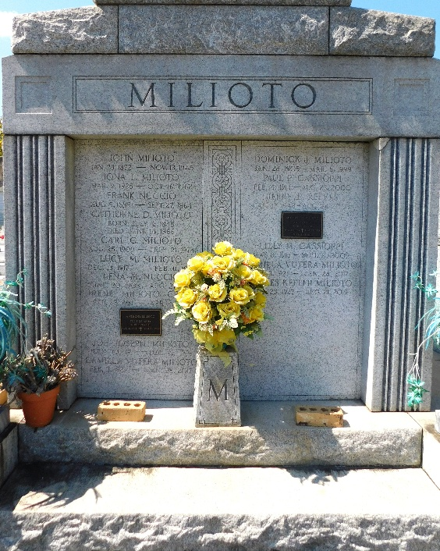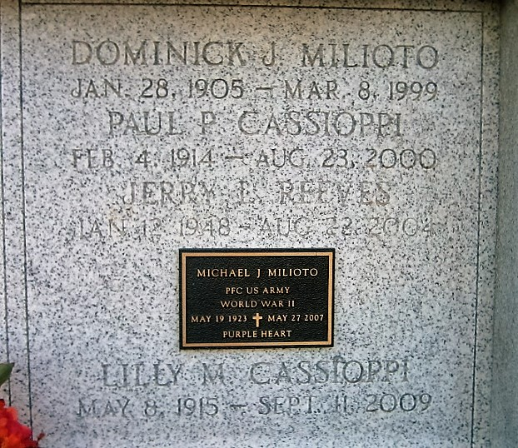
Photo by Mary Agnes Hammett Photo by Bobby

Jerry Lane Reeves on Sunday August 22, 2004 at 3:15 a.m.
Beloved husband of 27 years to Ann Milioto Reeves. Son of Floyd Reeves and the late Mae Murphy Reeves. Son-in-law of Camilla Milioto and the late Dominick Milioto. Brother-in-law of Catherine and Raymond Hartman, Rosemary (Minnie) and Ed Correia and Joan Milioto. Uncle of Travis, Allison and Brett Hartman, David and Daniel Correia. Lizzie the dog. Age 56, a native of Alabama and a resident of Metairie for the past 28 years.
Relatives and friends of the family also employees of Hewlette-Packard are invited to attend services. Visitation at Millet-Guidry Funeral Home, 2806 West Airline Hwy, Laplace on Thursday August 26, 2004 from 6:00 p.m. to 9:00 p.m. and on Friday from 8:00 a.m. until 10:00 a.m. Followed by Religious Services in the Funeral Home Chapel at 10:00 a.m. Burial in St. Peter Cemetery, Reserve. In lieu of flowers, contributions made in his name to the S.P.C.A. or a favorite charity.

The Times-Picayune, New Orleans, Louisiana
Aug. 24, 2004

