Anaise Marie (Froisy) Reine
November 1, 1861 – September 15, 1940

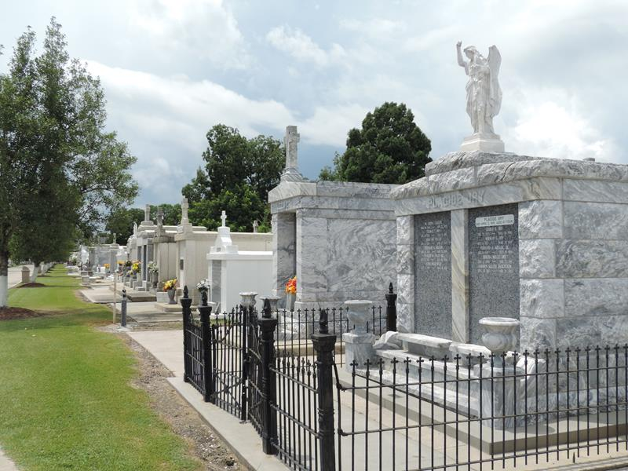

REINE – Of Reserve, La., on Monday morning, September 15, 1940, at 8 o’clock, Anaise Froisy Reine, wife of the late Fernand Reine, mother of Fernand, Robert, Noe and Augustin Reine and Mrs. Jack Cambre, aged 79 years.

Funeral took place from the Jules Millet funeral home, Reserve, La., on Tuesday evening, Septeber 17, 1940, at 3 o'clock, followed by religious services at St. Peter church, Reserve, La.

Interment in St. Peter cemetery, Reserve, La.

New Orleans States, Louisiana
Tuesday, September 17, 1940, p. 4

