Juliette (Clement) Reine
July 16, 1939 - September 17, 2024

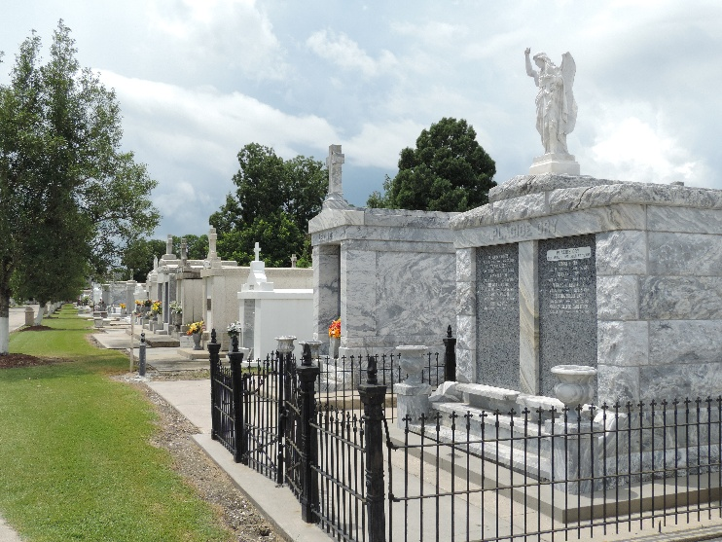

Juliette “Babe” Clement Reine was reunited with her husband in heaven on Tuesday, September 17, 2024. She was 85, a native of Reserve and a resident of LaPlace.
Beloved wife of the late Mack E. Reine, Jr. Mother of Michael (Alisha), Kent (Jane) and Barry (Belinda) Reine. Daughter of the late Noelie Vicknair Clement and Paul Clement. Sister of Farol Clement and the late Ernest “Chin” Clement, Barbara Simoneaux and Joseph “J.P.” Clement. Grandmother of Shelby, Macie, Addy, Nick, Alisha, Ashley, and Katie. Great grandmother of Mason, Kylie, Maiah, Myles, Knox, Rowan, Sutton, Briar, Swayzie and Jude.
The family would like to thank everyone at Notre Dame Hospice for the kindness and care given to her during her illness. Words cannot express how grateful we are for her caregiver, Annette Givens, for the kind and loving care given to our mom for the past 3 years.
Relatives and friends are invited to attend the services. A Funeral Mass will be celebrated at St. Joan of Arc Catholic Church on Monday, September 23, 2024, at 12:00 p.m. Visitation at church from 10:00 a.m. to 12:00 p.m. Interment will be in St. Peter Cemetery.

Millet-Guidry Funeral Home, LaPlace, Louisiana
September 20, 2024

