Mack Stephens Reine Sr.
December 17, 1912 – June 14, 1992

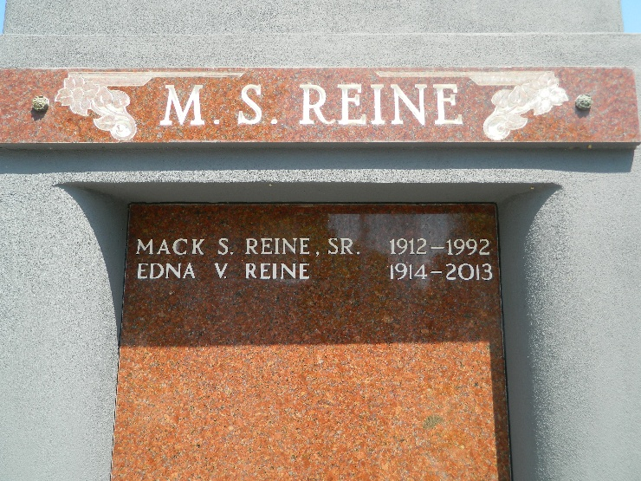

Mack Stephens Reine Sr., A Retired Chemical Plant Operator, Died Sunday At River Parishes Hospital In Laplace Of Complications From Prostate Surgery. He Was 79.
Mr. Reine Was A Lifelong Resident Of Laplace. He Retired In 1976 After A Long Career At Shell Chemical Co. In Norco. He And His Wife Developed Laplace Trailer Park, Which They Owned Until 1989.
He Is Survived By His Wife, Edna Vicknair Reine; A Son, Mack E. Reine Jr.; A Daughter, Mary Elizabeth 'Sis' Tamplain; A Sister, Lucille Reine Lyons Of Reserve; Five Grandchildren And Five Great-Grandchildren.
A Funeral Was Held Tuesday At St. Joan Of Arc Catholic Church In Laplace. Burial Was In St. Peter Cemetery In Reserve.
Times Picayune, New Orleans, Louisiana
June 19, 1992

