Cleven Remondet Sr.
January 23, 1928 – November 26, 2015

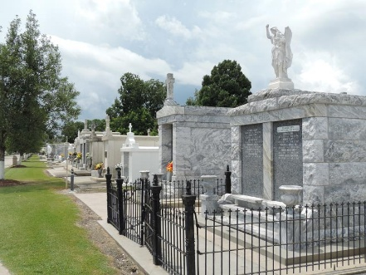

Cleven "Cup" Remondet, Sr. passed away on Thursday, November 26, 2015 at the age of 87. He was native of Vacherie, LA and a longtime resident of Reserve, LA. He was an employee with Godchaux Refinery for 50 years.

Beloved husband of the late Agnes Vicknair Remondet. Loving father of Charlene Roussel (Brent), Cleven Remondet, Jr. (Ann), Timothy J. Remondet (Julia) and Peter Remondet (Marlene). Also survived by many grandchildren and great grandchildren. Son of the late Dennis and Ida Klibert Remondet. Brother of the late Eloi Remondet, Lorina Poche, Oleida Poche, Aurelia Remondet, Eugenie Remondet, Naomi Roussel and Beatrice Hymel.

Relatives and friends are invited to attend the Funeral Mass at St. Peter's Catholic Church, 1550 Hwy 44, Reserve on Monday, November 30, 2015 at 11:00 a.m. Visitation will begin in church at 9:00 a.m. Interment in St. Peter Cemetery. To view or sign the online guestbook please visit
www.milletguidry.com
Times Picayune, New Orleans, Louisiana
November 27-29, 2015

