Dennis Joseph Remondet
October 8, 1925 – February 10, 2017

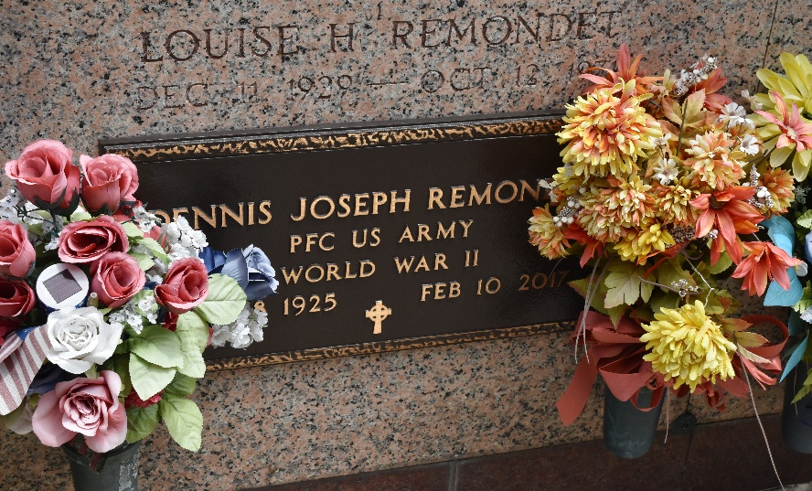

Dennis 'Two Marble' Joseph Remondet, died peacefully on Friday, February 10, 2017, at the age of 91. Dennis was born on October 8, 1925 in Reserve, LA the fourth child of the late Edward Joseph Remondet and Anastasia Klibert Remondet.
Beloved husband of 25 years to second wife, Frances Darlene Remondet and of the late first wife, Louise Hymel Remondet. Father of Ira Steven Remondet (wife, Linda), Mel Dennis Remondet (wife, Patricia) and Kim Mary Remondet (companion, Richard). Step-Father of Crystal Mueller (husband, Bill) and Rory Oncale (companion, Queenie). Grandfather of Ira Steven 'Snoopy' Jr., Trustin, Wesley, Trevor and Nicole Remondet, Tiffany and Stephanie Englade, Taylor, Monique and Peyton Oncale, Wesley, Laura and Caroline Mueller. Dennis was survived by 8 great-grandchildren. Brother of Ralph Remondet (wife, Suzanne), Marie Landry and the late Sidney, Claude, Edward, Charles and Leroy Remondet, Eva Idom and Denise Lambert. Brother-in-law of Edwina Hymel, Melba Hymel and the late William Idom, Patricia Remondet, Elma Remondet, Maurice Lambert, Ernest Landry, Sister Mary Osanna Hymel, OP, Ruth H. Klibert, Maizie H. Jacob, Daniel G. Hymel, Sr., Estelle H. Duhe, Numa J. Hymel, Jr., Shirley Hymel and Ray Hymel.
Dennis was a resident of LaPlace, LA. He was a World War II Veteran serving our country proudly. He served in Germany and fought until the end of World War II. He received an Honorable Discharge from the military service of the United States of America on August 8, 1946. He began his career at Godchaux's Sugar Refinery in the early 1950's and was one of the first to be hired at Kaiser in 1955 where he was employed until his retirement in 1986. Dennis enjoyed life with his wife, children, grandchildren, great-grandchildren and many relatives and friends.
Relatives and friends are invited to attend the Funeral Mass at St. Peter Catholic Church, 1550 Hwy 44, Reserve on Wednesday, February 15, 2017 at 12:00 p.m. Visitation at the church from 10:00 a.m. to 12:00 p.m. Interment in St. Peter Cemetery. Arrangements by Millet-Guidry Funeral Home.

The New Orleans Advocate, Louisiana
Feb. 12 to Feb. 15, 2017

