Harvey J. ‘Harry’ Remondet
October 5, 1899 – December 1, 1964

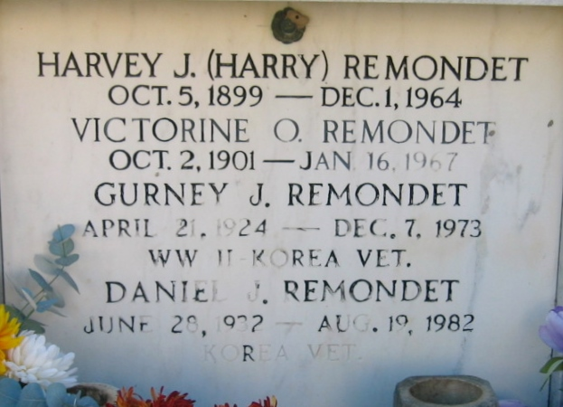
Photo by Bobby

REMONDET – On Tuesday,, December 1, 1964 at 7:40 o’clock p.m., Harry Remondet, beloved husband of Victorine Oubre, father of Hubert, Gurney, Garland, Daniel and Joseph Remondet, Mrs. Joseph Rodrigue, all of Reserve, La., Mrs. John Duhe of Laplace, La. And Harry Remondet of Norco, La., brother of Mrs. Celestine Rome of Marrero, La., also survived by 16 grandchildren, age 65 years, a native of Vacherie, La., and a resident of Reserve, La.

Relatives and friends of the family are invited to attend the funeral. Services from Millet Funeral Home, Reserve, La., on Thursday, December 3, 1964, at 11 o’clock a.m. Religious services at St. Peter’s Church, Reserve, La. Interment in St. Peter Cemetery, Reserve, La.

Times-Picayune, New Orleans, Louisiana
December 3, 1964

