Harvey Joseph Remondet Jr.
July 18, 1938 – April 21, 2021

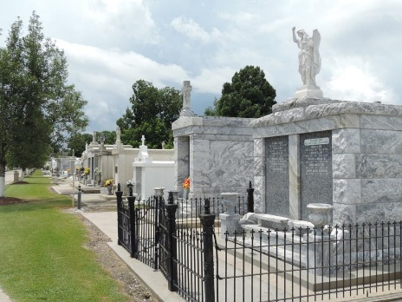

Junior Joseph Remondet peacefully passed away Wednesday, April 21, 2021, at the age of 82. Devoted husband, father, and grandfather, he is survived by his wife of 61 years, Regina Audiffred Remondet; children, Rachel Remondet Triche, James Remondet (Lori), and Ryan Remondet (Juliette); grandchildren, Hilary Scioneaux (P.J.), Meredith Smith (Jason), Janelle Bagnell (Wayne), Kallie Deslatte (Dustin), Jaymie Waguespack (Austen), Taylor Remondet, and Emily Triche (fiancé, Tyler LeBlanc); and eight great-grandchildren.
He was preceded in death by his parents, Victorine Oubre and Harry Remondet; and his siblings, Hubert Remondet, Garland Remondet, Gurney Remondet, Daniel Remondet, Harry Remondet, Albert Remondet, Doris Remondet Rodrigue, and Shirley Remondet Duhe.
A lifelong resident of Reserve, he proudly served in the U.S. Army and retired from Avondale Shipyard after 35 years. He was an active member of the Knight of Columbus Council #2436. He enjoyed hunting, gardening, throwing horseshoes, and celebrating life with his family.
Relatives, family, and friends are invited to attend services. Visitation at St. Peter Catholic Church, 1550 Hwy. 44, Reserve, LA on Saturday, April 24, 2021 from 9:00 a.m. to 11:00 a.m. followed by a Funeral Mass at 11:00 am. Burial in St. Peter Cemetery. Arrangements by Millet-Guidry Funeral Home, LaPlace, LA.

Times-Picayune, New Orleans, Louisiana
April 21-24, 2021

