LeRoy Remondet
March 2, 1936 – December 4, 2010

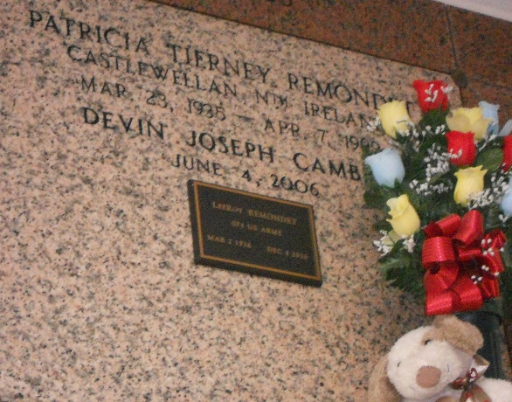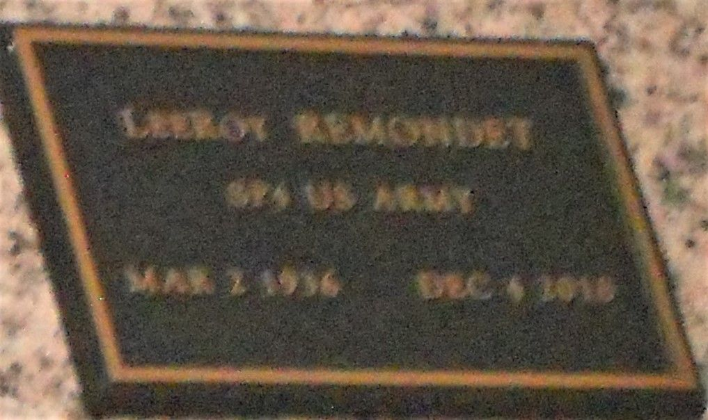
Photos by Team T-Lo

LeeRoy Remondet passed away on Saturday, December 4, 2010.
Beloved husband of the late Patricia Remondet. Father of Louis Remondet (Hope), Donald and Anna Mae Chenevert and Penny Bourgeois. Grandfather of Kristy, Vince Jr., John, Rachel and Melvin. Also survived by 1 great-grandchild. Son of the late Edward Sr. and Anastasia Remondet. Brother of Dennis, Sidney and Ralph Remondet, Marie Landry and the late Claude, Charles and Edward Remondet Jr., Eva Idom and Denise Lambert.
He was a Foster Parent for 50 years. Age 74. A native and resident of Reserve, La.
Relatives and friends are invited to attend services. Visitation at St. Peter Catholic Church, Reserve, La. on Tuesday, December 7, 2010 10:00 am to 11:30 am, followed by Mass at 11:30 am. Burial in St. Peter Cemetery. Arrangements by Millet-Guidry Funeral Home, LaPlace, La.

Times-Picayune, New Orleans, Louisiana
December 7, 2010

