Patricia (Tierney) Remondet
March 23, 1935 – April 7, 1999

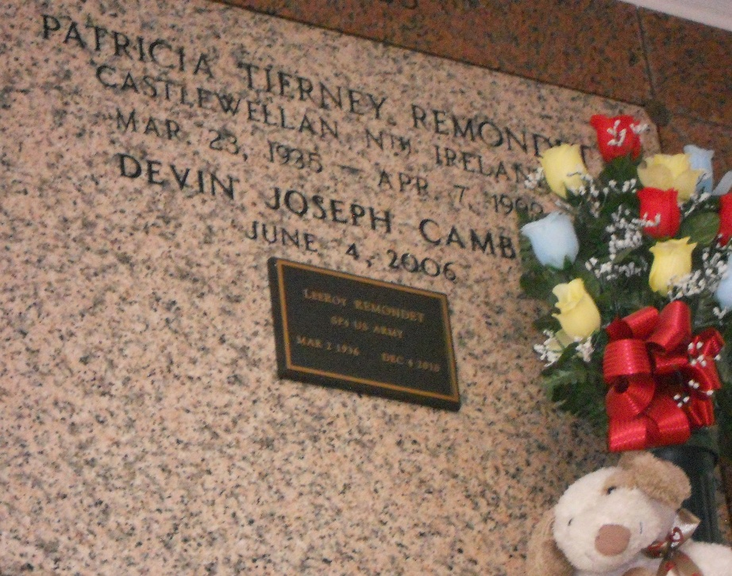
Photo by Team T-Lo

Patricia T. Remondet, 64, a native of Castlewellan, Northern Ireland, former resident of Reserve and resident of LaPlace for 28 years, died April 7, 1999.
She was a former teacher of Gramercy-Lutcher Jaycee kindergarten classes. She was a foster parent to more than 30 foster children.
She was the wife of Lee Roy Remondet and mother of Donald and Anna Mae Chenevert, Penny Bourgeois and Louis Remondet. She was also the sister of Maurine Cochrane and the late Seamus and Gene Tierney. She is also survived by four grandchildren; Kristy, Vince Jr., John and Rachel.
Services were held April 10 at St. Joan of Arc Catholic Church, LaPlace, with interment at St. Peter Cemetery, Reserve.

Unknown source

