Sidney J. Remondet
May 18, 1940 – June 10, 2016

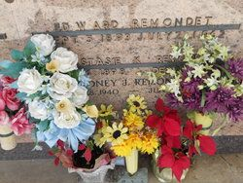
Photo by Team T-Lo

Sidney J. Remondet, age 76, passed away on June 10, 2016. He was a resident of Ormond Nursing and Care Center.

He was born on May 18, 1940 in Reserve, LA. Sidney is survived by his sister, Marie Landry and brothers, Ralph (Suzanne) and Dennis (Darlene) Remondet.

He was preceded in death by his parents, Edward J. and Anastasia Klibert Remondet, sisters, Eva Idom, Denise Lambert and brothers, Claude, Edward, Charles and LeeRoy Remondet. He was godfather to Linda McCarty and Roman Remondet. Sidney was retired from Riverlands Terminix, Inc.

A prayer service will be held at St. Peter's Church Chapel, 1550 Hwy. 44, Reserve on Tuesday, June 21, 2016 at 10:00 a.m. Interment in St. Peter's Cemetery in Reserve, LA. To view or sign the online guest book, please visit www.milletguidry.com

The New Orleans Advocate, Louisiana
Jun. 17 to Jun. 21, 2016

