Suzette (Trosclair) Remondet
September10, 1951 – December 4, 2011

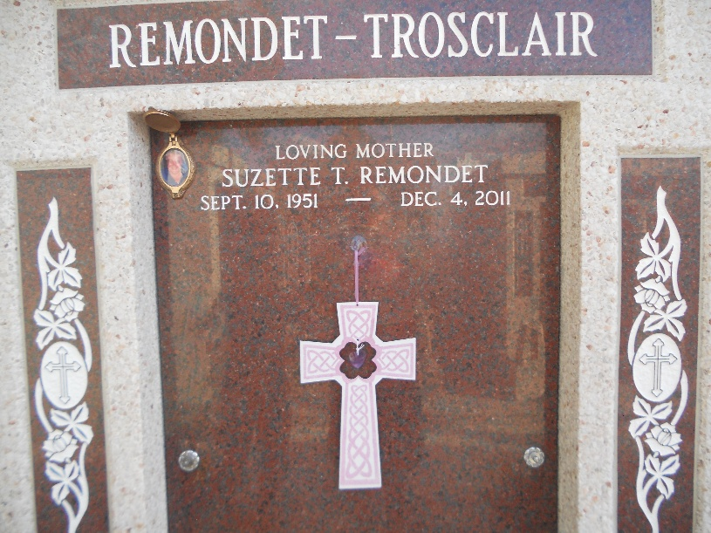
Photo by Team T-Lo

Suzette Trosclair Remondet passed away on Sunday December 4, 2011. Beloved mother of Dawn R. Triche, Cleven (C.J.) Remondet III (Carla), Houston Remondet (Ashley), Denny Remondet (Jamie), Garrette Trosclair (Dawn), Barrette Trosclair (Carla), and Laurette Scioneaux (Brian). Also survived by numerous grandchildren.
Daughter of the late Rene and Laura Mae Trosclair. Sister of Barnette and Everette Trosclair, Claudette LeBlanc, Evette Berthelot, Renette Ockman, Annette Roussel, Josette Trosclair, Lynette Canales and the late Paulette Remondet and Rene Trosclair, Jr. Age 60. A native of Garyville, LA and a resident of Reserve, LA.
Relatives and friends are invited to attend services. Visitation at Millet-Guidry Funeral Home, 2806 W. Airline Hwy., LaPlace, LA on Thursday, December 8, 2011 from 5:00 pm to 9:00 pm and on Friday from 8:00 am to 9:30 am, followed by Mass at St. Peter Catholic Church, Reserve, LA at 10:00 am. Burial in St. Peter Cemetery.

The Times-Picayune, New Orleans, Louisiana
December 6-7, 2011

