Lillie Mae (Keller) Reno
October 27, 1938 – December 14, 2001

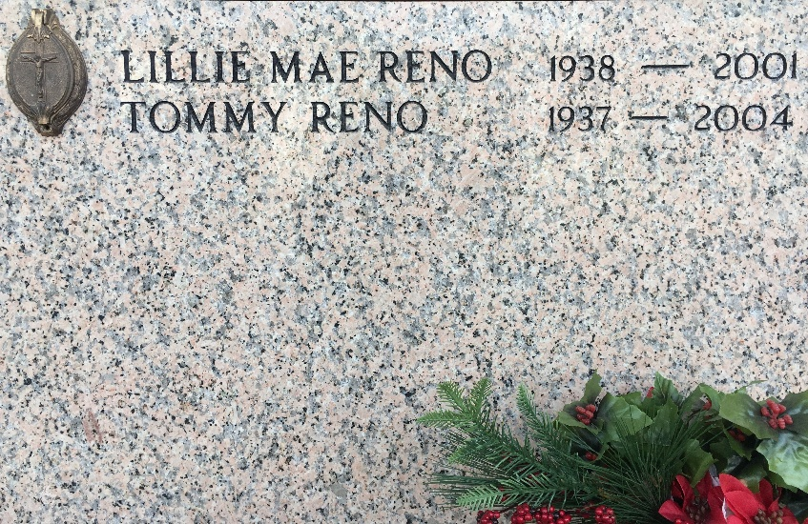
Photo by Team T-Lo

RESERVE - Lillie Mae Keller Reno, 63, a native and resident of Reserve, died Dec. 21.

She was the wife of Tommy Reno and mother of Tommye Lou, Tara, Timmy and Ty Reno.

She was the daughter of Mae Keller and the late Louis Keller and sister of Judith Duhon and Harold and the late Mark Keller. She is also survived by seven grandchildren.

Memorial services were Dec. 22 at St. Peter Catholic Church, Reserve.
L'Observateur, LaPlace, Louisiana
December 29, 2001

