Tommy Reno
1937 – October 5, 2004

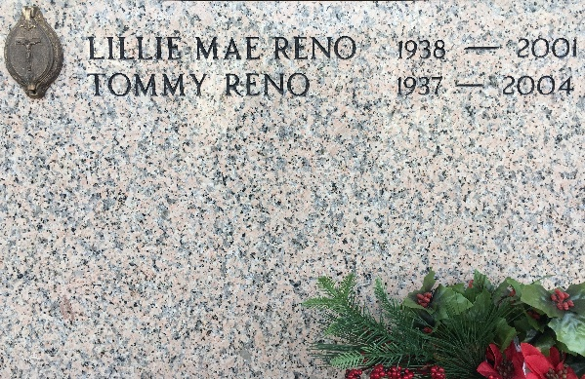
Photo by Team T-Lo

A retired operator with Kaiser Aluminum, he died at 7:30 a.m. Tuesday, Oct. 5, 2004, at his residence in Denham Springs. He was 67, a native of Manchac and a U.S. Army veteran.
Visitation will be at Seale Funeral Home chapel in Denham Springs on Thursday, Oct. 7, from 3 p.m. until a memorial service at 4 p.m., conducted by Deacon Peter Schlette.
Survived by his wife, Marjorie A. Reno; two daughters and a son-in-law, Tommye Lou Reno and Joe Schmidt and Tara Reno; two sons and daughters-in-law, Timmy and Krissy Reno and Ty and Jessica Reno; three stepdaughters, Ann Marie Robert, Mona Ballard and Tommie Ann Deshotel; two stepsons, Paul and Mark Fabre; seven grandchildren; a sister, Lula Bell Cantrell; a brother, Gary Reno; a special friend, Tra "Julio" Ballard.
Preceded in death by his parents, Louis Tom and Ethel Mae Reno; former wife, Lillie K. Reno; a sister, Debrah Ann Reno; and a brother, Andrew John Reno.
He was a member of Immaculate Conception Catholic Church in Denham Springs.
Memorial donations may be made to St. Jude Children's Research Hospital, P.O. Box 3704, Memphis, TN 38173-9984.
The Advocate, Baton Rouge, Louisiana
Oct. 7, 2004

