Stephanie (Restel) Revolta
March 21, 1963 – July 13, 2005

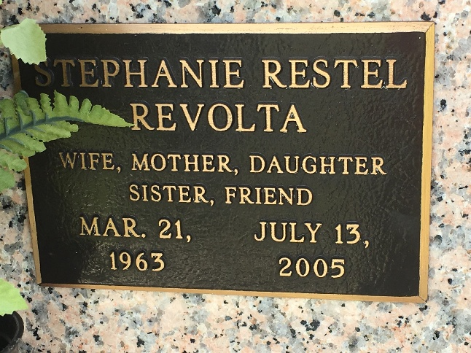
Photo by Team T-Lo

Stephanie (Stevie) Restel Revolta, passed away on Wednesday, July 13, 2005.
Wife of Joseph H. Revolta. Mother of Daniel R. Moldaner and Sabrina A. Moldaner. Stepmother of David, Joshua and Nanci Revolta. Stepgrandmother of Mason Revolta. Daughter of James D. and Wunita Restel. Sister and sister-in-law of James Jr., Marianne Restel and Michael and Lynn Restel. Sister-in-law of Wayne and Sylvia Kimball, E.J. Revolta, Jr., John and Sandra Jimerson and Susan Warner. Also survived by aunts, uncles, cousins, nieces and nephews.
She attended St. Rita's School, Harahan, LA, Archbishop Chappelle High School and received a B.A. from UNO. A member of the Bumper to Bumper Bowling League and the Office Manager for Wholesale Siding and Supply Company, Jefferson, LA. Age 42 years. A native of Lafayette, LA and a resident of LaPlace, LA for the past 5 years.
Relatives and friends of the family are invited to attend services at MILLET-GUIDRY FUNERAL HOME, 2806 W. Airline Hwy., LaPlace, LA on Monday, July 18, 2005, from 9:00 a.m. until 11:00 a.m. Followed by Religious Service at the Funeral Home Chapel at 11:00 a.m. Burial to be private at a later date.
The Times-Picayune, New Orleans, Louisiana
Jul. 17, 2005
**

LaPlace woman dies in Elmwood shooting
Remembered by family as generous and devoted to children

JEFFERSON – A shooting at Wholesale Siding Supply in Elmwood resulted in the murder of a LaPlace resident and her co-worker, before the gunman shot himself. A 911 emergency call was received around 3:30 p.m. Wednesday from LaPlace resident Stephanie Revolta, 42, an office manager, when data entry clerk Barbara Cavalier's husband, Chris Cavalier, entered the business after harassing his wife at work all day by repeatedly calling her, according to Col. Robert Garner with the Jefferson Parish Sheriff's Office. Garner confirmed that Barbara and Chris had been married for seven years and she left him six months ago and he had no idea where she lived but did know where she worked. It was said, by the Owner of the business Billy Deckwa Jr., that Chris came into the business and told Barbara she was going to die that night and so was he.

Abstracted from L’Observateur.com
July 18, 2005

