Ernest Reynaud Sr.
October 2, 1933 – March 10, 2023

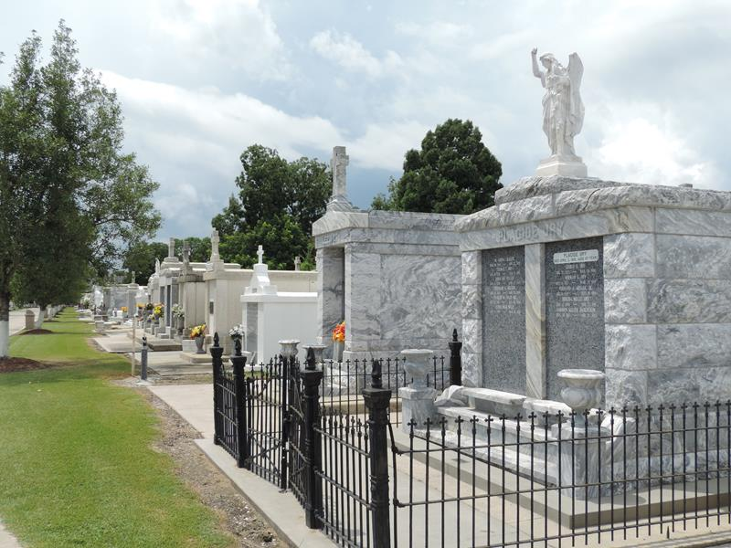

Ernest Reynaud, Sr. affectionately known as “CoCo” transitioned from his earthly life on Friday, March 10, 2023 at the age of 89. Ernest was a native of Norco, LA and a resident of LaPlace, LA.
He was born on October 2, 1933 to the late Irvin Reynaud, Sr. and Viola Narcisse. He was the husband of the late Myrtle Burfict Reynaud. Father of Diane Reynaud Perrilloux, Dena Burfict, Bernard, Michael, David, Patricia, Linda, Tracee, Leon and Konrad Reynaud and the late Ernest Reynaud, Jr., Eric and Jeffrey Reynaud and Eugene Schofield. Brother of Anita Reynaud of LaPlace, LA and the late Adam and Walter Schofield, Mary Wallace, Mathilda Johnson, Irvin Reynaud, Jr. and Frank Reynaud. He had 22 grandchildren, and a host great grandchildren and great great grandchildren. He also survived by a host of nieces, nephews, cousins, other relatives and friends.
Ernest was employed by the St. Charles Parish Government in the Waterworks Department.
Relatives and friends of the family, Priest and Parishioners of Sacred Heart Catholic Church and all neighboring churches are invited to a Mass of Christian burial at 11:00 am on Saturday, March 18, 2023 at Sacred Heart Catholic Church, 401 Spruce Street, Norco, LA 70079. Visitation from 9:00 am until the time of Mass at the above- named Church. Interment St. Peter Catholic Church Cemetery, 1550 LA-44, Reserve, LA 70084.

Patrick H. Sanders Funeral Home, LaPlace, Louisiana

