John Davis Reynaud III
March 4, 1951 – August 27, 2010

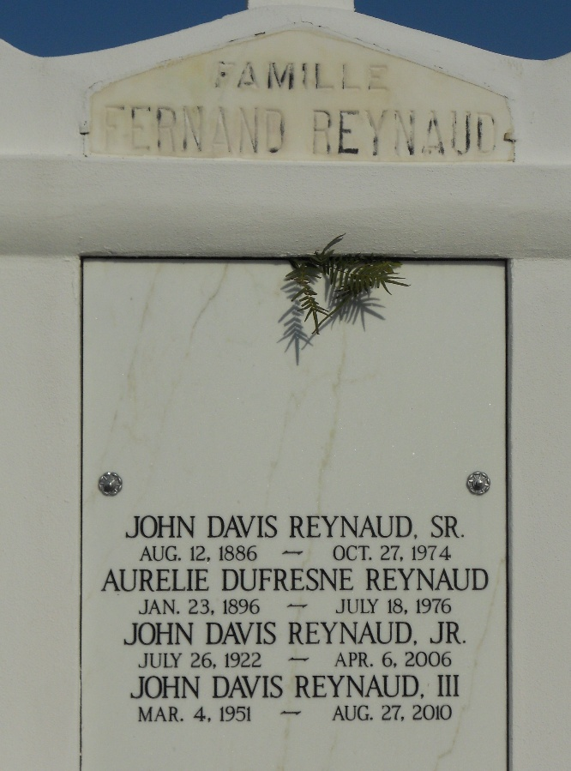
Photo by Team T-Lo

John "Jud" Davis Reynaud, III passed away on Friday, August 27, 2010 at Tulane Medical Center at the age of 59 a resident of Convent, Louisiana.
Beloved husband of Pamela Nirk Reynaud. Father of Monique Reynaud Levron (Barry) and John "Jean" Davis Reynaud, IV (Philonese). Grandfather of Chloe and Clair Reynaud, Brady, Madison and Morgan Levron, Step-father of Rendel A. Dalton,II.; Brother of Cheryl Reynaud Tharp, Keith M. Reynaud, David S. Reynaud, Leslie Reynaud Boyington, Mark J. Reynaud, Michael V. Reynaud, Jennifer Reynaud Tracy and Jason P. Reynaud.
He was preceded by his parents John Davis Reynaud, Jr. and Audrey Champagne Reynaud. Step-mother, Nathalee Boone Reynaud.
Proprietor of Design Woodwork Company a Master Builder & Artisan of the Trades. Recipient of the 1997 Golden Hammer Award and the 1998 Louisiana Preservation Award. He was a Lance Corporal in the United States Marine Corp Reserve from 1970 -1976.
Relatives and friends are invited to attend a memorial service at St. John the Baptist Catholic Church, 2349 Hwy 18, Edgard, Louisiana, on Thursday, September 2, 2010 at 11:00 am. Visitation will begin at 10:00 am until service time at St. John the Baptist Catholic Church. Interment will follow in St. John the Baptist Cemetery. JACOB SCHOEN & SON Funeral Home is in charge of Arrangements.

Legacy Remembers
Aug. 30, 2010

