John Davis Reynaud Jr.
July 26, 1922 – April 6, 2006

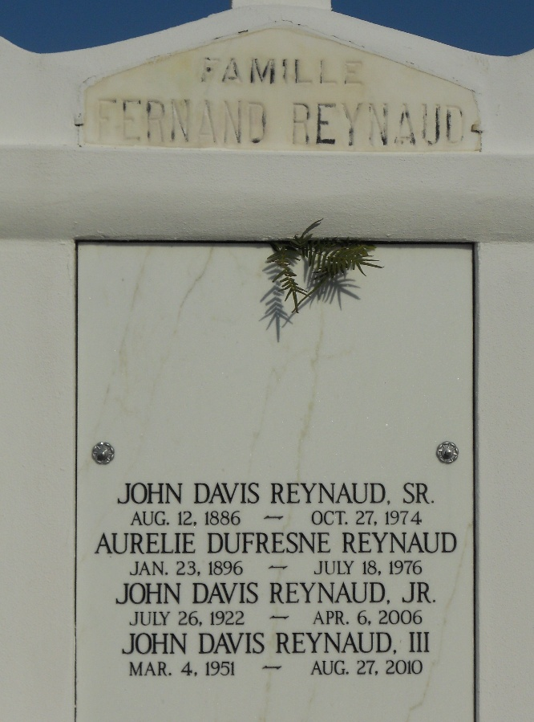
Photo by Team T-Lo

John Davis Reynaud, Jr., owner of Reynaud Construction Company, Inc. and Maison Lafitte Apartments, passed away on Thursday, April 6, 2006.
He is preceded in death by his wife Audrey Champagne Reynaud and Nathalee Boone Reynaud by second marriage. He is survived by his children, Cheryl Ann Reynaud Tharp and her husband Henry Tharp, John Davis Reynaud, III and his wife Pamela Nirk Reynaud, Keith Martin Reynaud, David Stanton Reynaud, Mark Jerome Reynaud, Leslie Reynaud Boyington, Michael Victor Reynaud, Jennifer Reynaud Tracy and her husband Philip Tracy, and Jason Patrick Reynaud and his wife Melissa Stiebing Reynaud; one sister, Melba Reynaud Desroche, 16 grandchildren and 14 great grandchildren. His parents Aurelie Dufresne Reynaud and John Davis Reynaud, Sr., and a sister, Enid Reynaud Tassin preceded him in death.
Mr. Reynaud, a native of Lucy, LA, lifelong resident of Metairie, LA and U. S. Marine Corp World War II Veteran was 83.
Relatives and friends are invited to attend the Visitation and Funeral Mass. Visitation will be at the temporary location of Jacob Schoen and Son Funeral Home (Lamana-Panno-Fallo), 1717 Veterans Memorial Blvd. at Bonnabel Blvd., Metairie, LA on Sunday, April 9, 2006 between the hours of 6:00 PM and 9:00 PM. The Funeral Mass will be celebrated at St. John the Baptist Catholic Church, Edgard, LA on Monday, April 10, 2006 at 10:00 A.M. Visitation will also be at the Church on Monday from 9:00 A.M. to 10:00 AM. Interment will follow the Mass in St. John the Baptist Cemetery, Edgard, LA.

The Times-Picayune, New Orleans, Louisiana
Apr. 9, 2006

