Myrtle (Burfict) Reynaud
March 19, 1931 – October 20, 2009

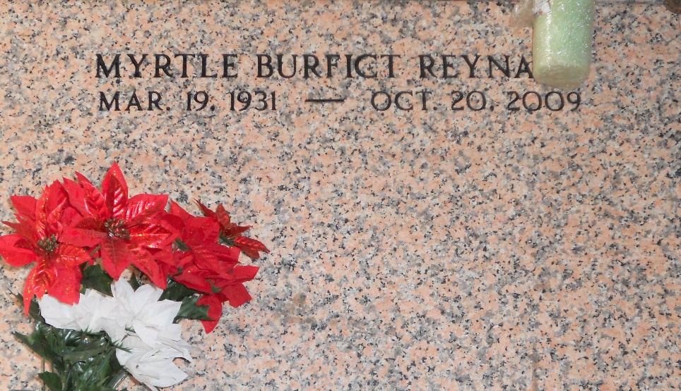
Photo by Team T-Lo

Myrtle Burfict Reynaud on Tuesday, October 20, 2009 at East Jefferson Hospital, Metairie, LA.
Daughter of the late Evelina and Nicholas Burfict. Wife of Ernest Reynaud, Sr. Mother of Dena Burfict, Diane (Burnell) Perrilloux, Leon, Patricia, David (Nancy), Michael (Katrina), Bernard, Eric, Konrad, Tracee, and Linda Reynaud, Eugene Scofield, the late Jeffery and Ernest Reynaud, Jr. Sister of Ceola Gerard, Olivia Fenroy, the late Percy, Joseph and Levi Burfict. Sister in law of Anita, Frank and Mary Reynaud. Preceded in death by a grandson, Stanley Cook, Jr. Also survived by a devoted friend, Tessy Troxclair, 27 grandchildren, 36 great grandchildren, and a host of nieces, nephews, other relatives and friends. Age 78 years. A native of Reserve, LA and a resident of Norco, LA and most recently of LaPlace, LA.
Relatives and friends of the family, also priest and parishioners of Sacred Heart Catholic Church and all neighboring churches are invited to attend the Mass of Christian Burial at Sacred Heart Catholic Church, 401 Spruce Street, Norco, LA, on Saturday, October 24, 2009 at 12 Noon. Father Terry Becnel, Celebrant. Interment St Peter Cemetery, Reserve, LA. Visitation at the above named church from 10:30 AM until Mass time. Rosary at 11:00 AM. SERVICED BY ROBOTTOM

The Times-Picayune, New Orleans, Louisiana
October 23, 2009

