Aline (Badeaux) Reynolds
October 1, 1930 – April 22, 2018

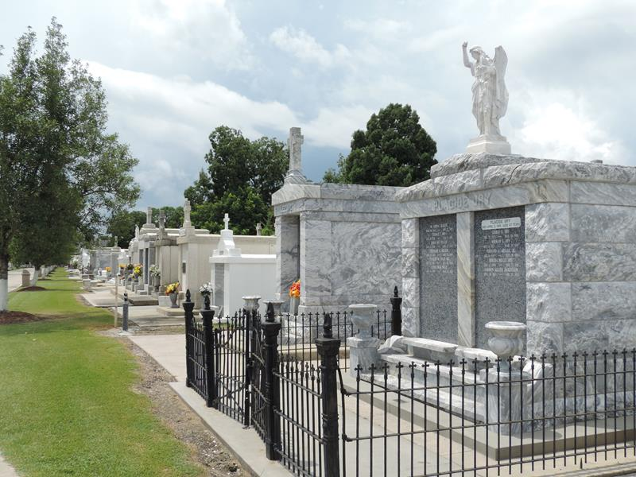
Photo by Team T-Lo

Aline Badeaux Reynolds, loving wife and mother, died on Sunday, April 22, 2018 at the age of 87. She was born in Jefferson Parish on October 1, 1930, and she graduated from Jefferson High in 1947. She was a resident of Metairie, Louisiana for 66 years.
She worked for several years as a secretary and bookkeeper at Krauss and later with Village Lady and Grande Prix but spent much of her life as a volunteer with Multiple Sclerosis, Junior Diabetes Research Foundation, and Easter Seals. She received the "Great Volunteer Award" for her many years of contribution. She was also an active member in the following organizations: Pioneer Partner Life Club, First Friday Group, and Our Lady of Divine Providence Adoration Group. She loved holding garage sales, gambling at the casinos, and bowling in various leagues with dear friends.
She is survived by her devoted husband of 67 years, Ruben "Jay" Reynolds, Jr., who passed away shortly after; son, Vincent Reynolds and his wife, Carol Carter; daughter, Victoria Reynolds (Dranguet); and daughter, Vanessa Reynolds and her husband, George "Billy" Powers, III. Aline, aka Granny, is survived by nine grandchildren and ten great-grandchildren: Sarah Reynolds (husband, Brian Thiel), son Joshua and daughter Rebecca; Laura Reynolds (husband, Mark van Vrancken), daughter Emma; Jennifer Reynolds (husband, Pauli Juneau), son Francis and daughter Genevieve; Catherine Reynolds (husband Robert "Chip" Campbell), son Carson; Alicia Powers (fiancee, Josh Fox), daughters Fiona and Callie; Heather Powers (husband, Keith Hooks), sons Ruben and Julian; Brittany Dranguet; Larissa Powers; and Beau Powers. She is also survived by her sister, Gladys Badeaux Booth, seven nieces and nephews, and numerous great-nieces and great-nephews.
She was preceded in death by her parents, Vincent Badeaux and Mary Ellen Parr Badeaux; two brothers and their respective wives: Vincent Wallace Badeaux and Amelia Fousse and Wilfred Joseph Badeaux and Joan; as well as two sisters, Mary Ellen Badeaux and Alice Badeaux.
Visiting hours for Aline and Jay will take place at the Garden of Memories Funeral Home, 4900 Airline Dr. in Metairie, LA on Tuesday, May 1, 2018 from 10:00 am until 12:00 noon with a Funeral Mass in the chapel at 12:00 noon officiated by Fr. Mike Mitchell, and burial will follow at 2:00 pm at St. Peter's Cemetery, 1550 Hwy. 44 in Reserve, Louisiana.
In lieu of flowers, please make a donation in Aline's name either to Multiple Sclerosis or for Masses said at Our Lady of Divine Providence in Metairie, Louisiana.
Aline's family wishes to extend a heartfelt thanks to the caring staff at Canon Hospice in Metairie. You made an otherwise tragic situation into an act of love. Our parents were together until the end and you made that possible.

The New Orleans Advocate, Louisiana
Apr. 27 to May 1, 2018

