Ida (Duhe) Richarme
February 21, 1893 – February 26, 1959

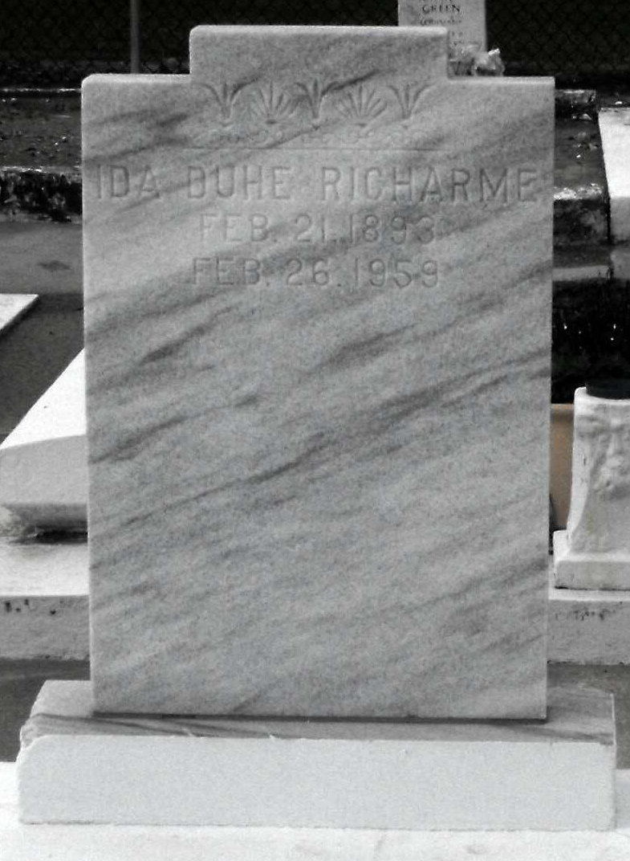
Photo by Mary Agnes Hammett

RICHARME – On Thursday, Feb. 26, 1959, at 1 o’clock p.m. Ida Duhe, wife of the late James O. Richarme Sr., mother of Mrs. O. W. Hayden of Houston, Tex., Ethel B., Davis P. and James O. Richarme Jr. Also survived by five grandchildren.
Relatives and friends of the family are invited to attend the funeral from the home of Tharp-Sontheimer-Tharp, Inc., 4127 South Claiborne Ave. (parking entrance on Milan St.) on Saturday morning, Feb 28, 1959, at 9:45 o’clock, followed by Requiem Mass at St. Matthias church, Broad and Gen. Pershing. Interment Reserve, La.

The Times-Picayune, New Orleans, Louisiana
February 28, 1959

