James Oscar Richarme Sr.
December 8, 1888 – October 2, 1943

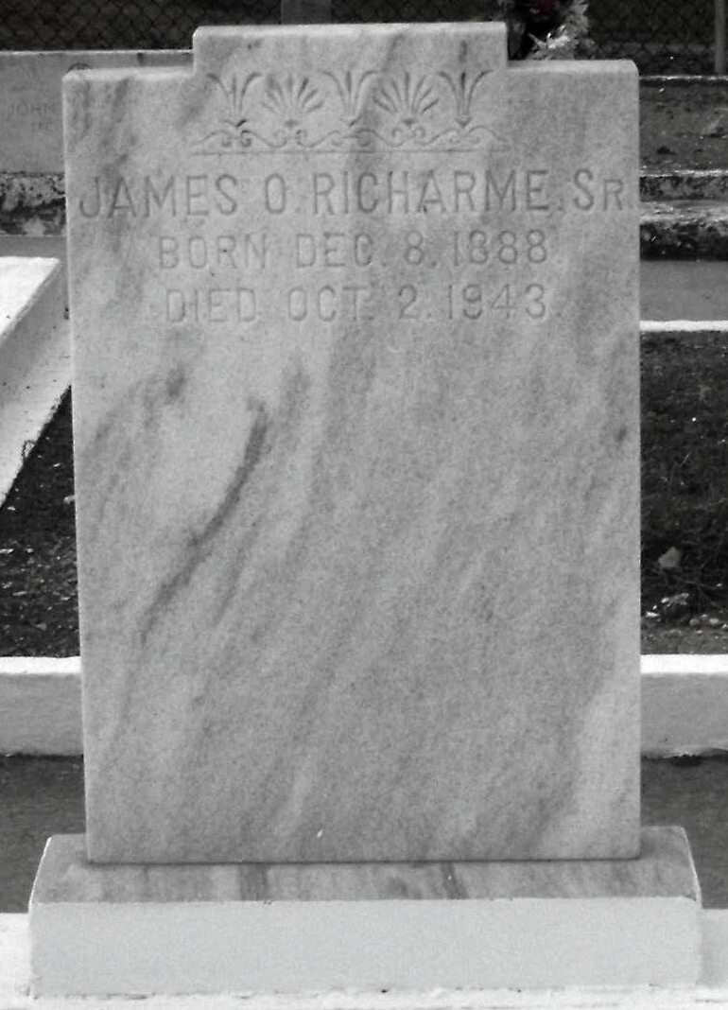
Photo by Mary Agnes Hammett

RICHARME – At Norco, La., on Saturday, October 2, 1943, at 11:20 o’clock p.m. James O. Richarme, Sr., beloved husband of Ida Duhe and father of Mrs. Rachel Heyden of Houston, Tex., Captain Dave Richarme of Camp Blanding, Fla., Billie and James O. Richarme, Jr., Brother of Mrs. I. J. Shubert, Mrs. J. C. Delaune, John, Logan, Joseph and the late Thomas and Lillian Richarme; aged 54 years.
Relatives and friends of the family are invited to attend the funeral, which will take place on Monday, October 4, 1943, at 1 o’clock p.m. from his residence, Norco, La. Interment St. Peter cemetery, Reserve, La. Jules Millet Funeral Home, Reserve, La., in charge

The Times-Picayune, New Orleans, Louisiana
October 4, 1943

