Earl K. "Bo" Richert
August 8, 1956 - September 10, 2023

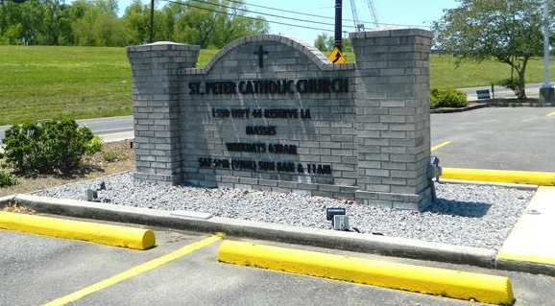

Earl K. "Bo" Richert, born on August 8, 1956, departed from this world on September 10, 2023. Mr. Richert was a resident of LaPlace, LA.
He is survived by his devoted wife, of 47 years, Cheryl Cox Richert; son, Jason Richert; three cherished grandchildren, Austin Richert, Abby Richert, and Mason Richert; one brother, R. Kirk Richert; two sisters, Karen Delcambre (husband Rickey) and R. Kris Richert; sisters-in-law, Debbie Delaune Richert and Jeannine Scontrino Richert; brother-in-law, Todd Cox (companion Gary Guillen); godchild and nephew, Chad Richert (wife Sarah); nieces, Shannon Breaux (husband Shane), Jennifer Columbia, Analiese Richert, and Aria Richert; nephews, Kyle (wife Nicole), Rudy “RJ” Perciful, Jr. (wife Holly), Jerry Cox III, and Michael Cox; great nephews and nieces, Chris Richert, Collin Richert, Laine Breaux, Aidan Breaux, Alexis Breaux, Seth Richert, Jacob Columbia, Jolie Columbia, Taylor Cox, Dylan Cox and Maureen Perciful; and great-great niece and nephew, Ashton Ballard and Braelyn Ballard.
Earl “Bo” was preceded in death by his parents, Rudy C. Richert and Delta Gaspard Richert; brother, Rudy Keith Richert; and brother-in-law, Jerry Cox, Jr.
Earl “Bo” was loved by all who knew him. His life was marked by the love and warmth he shared with his family. He loved giving to the community so much that his Christmas decorations took up the front of his house and the front yard of two of his neighbor’s houses. He dressed as Santa Claus and allowed children and adults to sit on his lap to take pictures and tell “Santa” what they wanted for Christmas and sent them on their way with candy or other trinkets. His legacy lives on through the memories and bonds he created with those he held dear. May he rest in peace, forever in our hearts.
Relatives and friends are invited to attend the Visitation and Funeral Mass at Millet-Guidry Funeral Home, 2806 W. Airline Hwy., LaPlace, LA on Saturday, September 16, 2023. Visitation from 8:30 a.m. to 12:00 p.m. followed by a Funeral Mass at 12:00 p.m. Rev. Ray Hymel, from St. Hubert Parish in Garyville, LA will be Celebrant of the Mass and will conduct the funeral services. Interment in St. Peter Cemetery, Reserve, LA.
In lieu of flowers, memorial contributions may be made to the family to offset funeral expenses.

Millet-Guidry Funeral Home, LaPlace, Louisiana

