Christopher Michael Richoux
December 27, 1979 – January 16, 2016

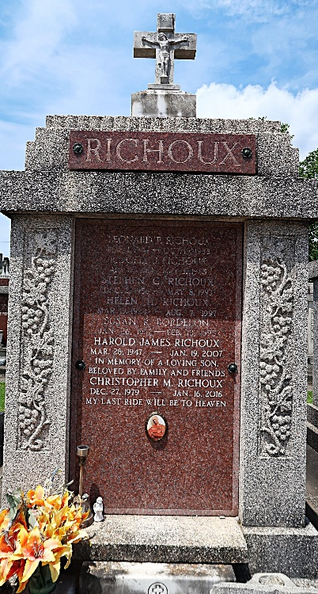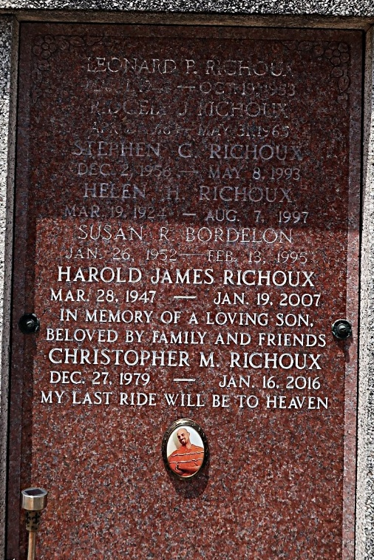

Christopher Michael Richoux passed away on Saturday, January 16, 2016. He was 36, a native of Metairie, LA and a resident of LaPlace, LA.
Beloved son of Judy Walden and the late Stephen Richoux. Stepson of Morris Walden. Brother of Jeff, Marlin, Shane and Ramona Walden. Grandson of the late Helen and Rigley Richoux and Theresa and Walter Tassin. Husband of Marsha Richoux. Stepfather of Jeremiah Schoepf. Also survived by many aunts, uncles, nephews, nieces, cousins and friends. Christopher was loved by many and will be greatly missed but not forgotten.
Relatives and friends are invited to attend the visitation at Millet-Guidry Funeral Home, 2806 W. Airline Hwy, LaPlace, on Thursday, January 21, 2016 from 5:00 p.m. until 9:00 p.m. Visitation on Friday at St. Joan of Arc Catholic Church, 529 W. 5th St., LaPlace, from 9:00 a.m. until 11:00 a.m. Mass will be celebrated at 11:00 a.m. Interment in St. Peter Cemetery.

The New Orleans Advocate, Louisiana
Jan. 19 to Jan. 21, 2016

