Harold James Richoux
March 28, 1947 – January 19, 2007

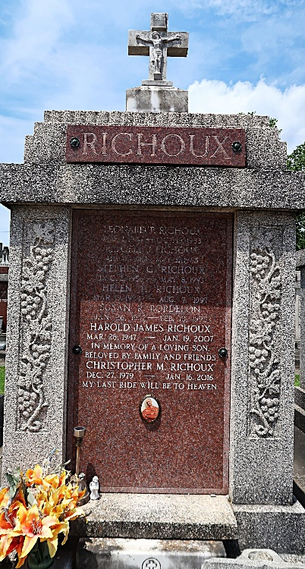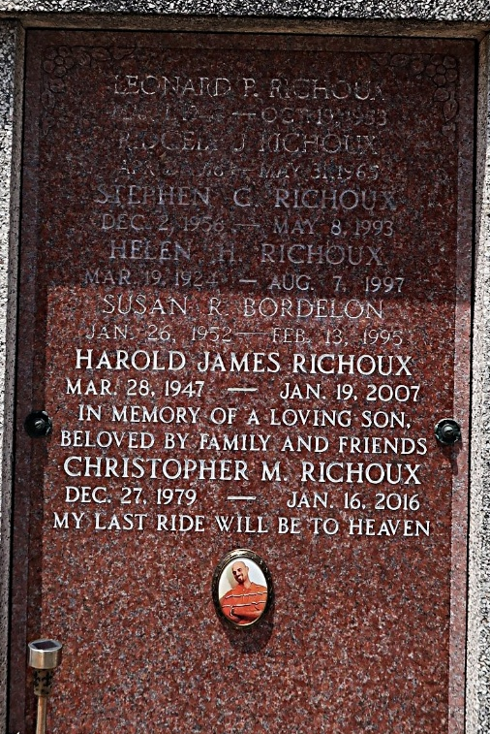

Harold Richoux on Friday, January 19, 2007 at 7:04 am. Beloved father and father-in-law of Chanda and Kevin Allsop, Joey Wehrwein, Damian Scott and Aimee Wehrwein and Tina Richoux. Son of the late Ridgley and Helen Richoux. Brother of the late Lenny Richoux, Susan Bordelon and Stephen Richoux. Grandfather of Allison, Imani, Elspeth, Ashlyn, Serenity and Evelynne. Age 59. A native of Laplace and a resident of Metairie.
Relatives and friends of the family are invited to attend services. Visitation at Millet-Guidry Funeral Home, 2806 W. Airline Hwy., Laplace on Thursday, January 25 from 10 am to 12 noon. Followed by memorial services at the funeral home chapel at 12 noon. Burial to be private at a later date.

The Times-Picayune, New Orleans, Louisiana
Jan. 24, 2007

