Dianna (White) Rivers
January 15, 1945 – April 14, 2013

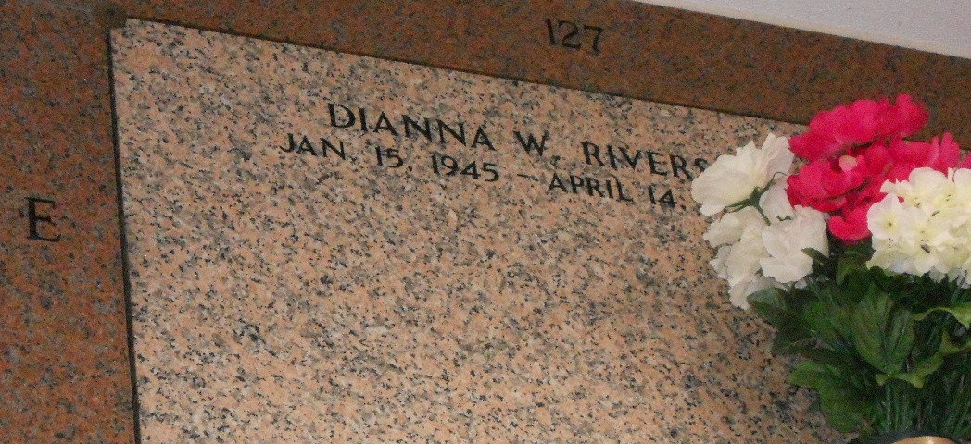
Photo by Team T-Lo

DIANNA W. RIVERS on Sunday, April 14, 2013 at River Parishes Hospital, LaPlace, LA.
Daughter of the late William "Billy" and Ida White Wife of Irvin Rivers, Sr. Mother of Irvin Rivers, Jr. (LaSoyna) and Cynthia Rivers Sister of Marcell White (Alice), the late Edward "Tony" White and Clarence "Billy" White Also survived by three grandchildren, Jacolbi, Camry and Cameron Rivers, two devoted friends, Viola Cook and Sylvia Clayton, and a host of nieces, nephews, other relatives and friends. Age 68 years. A native and resident of Reserve, LA.
Relatives and friends of the family, also priest and parishioners of Our Lady of Grace Church and all neighboring churches are invited to attend the funeral Mass at Our Lady of Grace Catholic Church, 772 Highway 44, Reserve, LA. on Thursday, April 18, 2013 at 11:00 AM Father Christopher Amadi, SSJ, Celebrant. Interment St Peter Cemetery, Reserve. LA Visitation at the above named church from 9:00 AM until Mass time. SERVICED BY ROBOTTOM

The Times-Picayune, New Orleans, Louisiana
April 16-17, 2013

