Robbie J. Rivers
September 12, 1967 – December 6, 2006

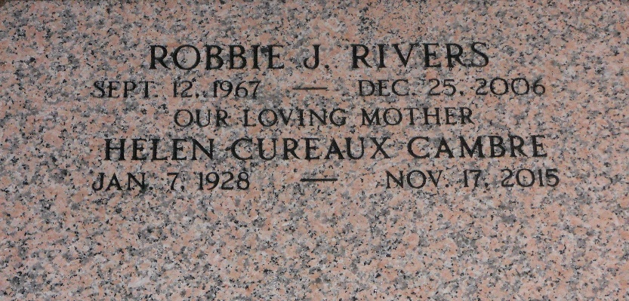
Photo by Team T-Lo

Robbie (Lil Bob) Rivers, on Monday, December 25, 2006 at River Parishes Hospital, Laplace, LA.
Son of Barbara C. Rivers and the late Ronald Rivers, Sr. Brother of Rodney Rivers and the late Ronald Rivers, Jr. Brother-in-law of Nicole Rivers. Father of Rhy'al Mazique. Uncle of Joi and Raigan Rivers. Grandson of Helen Cambre, and the late Edgar Cambre, Sr., Clarence and Armacey Rivers.
Also survived by a host of aunts, uncles other relatives and friends. Age 39 years. A native and resident of Reserve, LA.
Relatives and friends of the family, also priest and parishioners of Our Lady of Grace Catholic Church and all neighboring churches are invited to attend the Mass of Christian Burial at Our Lady of Grace Catholic Church, 772 Highway 44 (River Road), Reserve, LA. on Saturday, December 30, 2006 at 10:30 AM. Father Joseph Rodney, Celebrant. Interment St. Peter Cemetery, Reserve, LA. Visitation at the above named church from 9:00 AM until Mass time.

The Times-Picayune, New Orleans, Louisiana
December 29, 2006

