Janet (Chenier) Rizzuto
October 16, 1940 – November 29, 2016

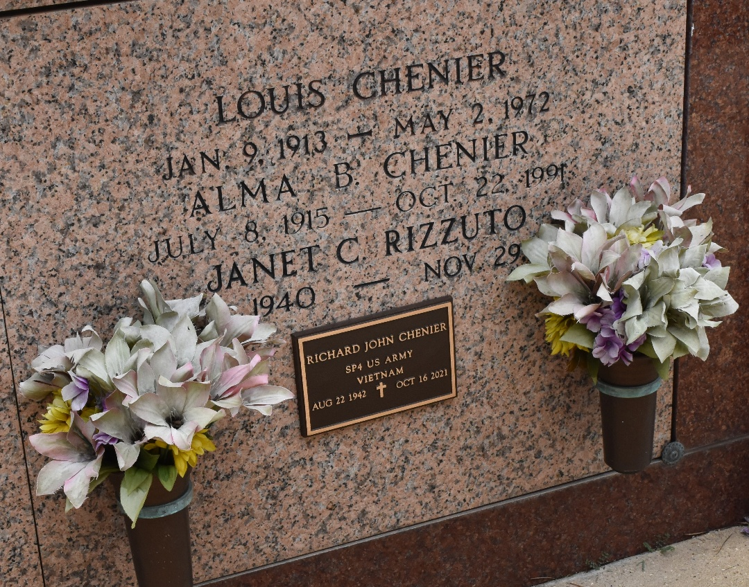

Janet Chenier Rizzuto, age 76, passed away on November 29, 2016.
She is survived by her son, Frank Rizzuto (Cathy); brothers, Gerald M. Chenier (Laura), and Richard J. Chenier; sisters, Joyce C. Petit (Claude), and Susan C. Loupe (Norbert); a sister-in-law Phyllis M. Chenier as well as 2 grandchildren , Ashley and Jacob Rizzuto and numerous nieces and nephews.
She was preceded in death by her parents, Louis and Alma Bourgeois Chenier and a brother, Donald Chenier.
A visitation in her honor will be held on Thursday, December 1, 2016 from 8:00 a.m. until 10:00 a.m. at St. Peter Catholic Church in Reserve, LA followed by a Mass of Christian Burial at 10:00 a.m.

ROSE LYNN FUNERAL SERVICES, Lutcher, Louisiana

