Hewitt Patrick Robert
January 5, 1928 – September 29, 2018

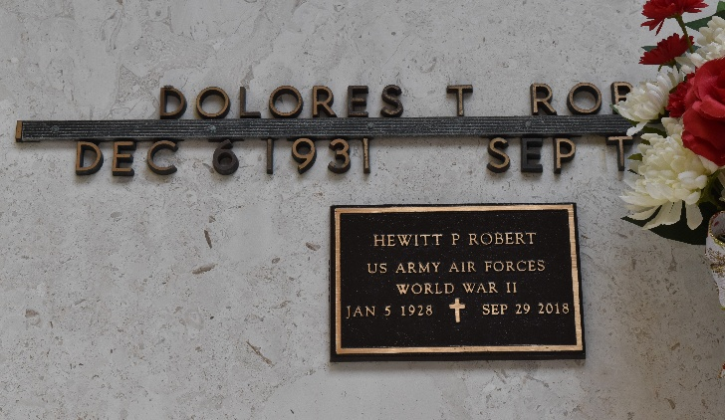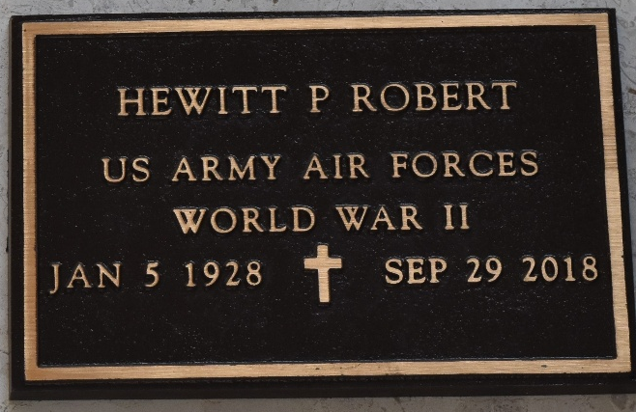

Hewitt P. “JAP” Robert died peacefully in his sleep on Saturday, September 29, 2018 at the Southeast LA Veterans Home in Reserve, LA.
He is survived by his 3 children, Loretta R. Webre (Bobby), Hewitt P. “PAT” Robert, Jr. (Lois), and Wilfred J. Robert; 9 grandchildren, Dolores B. Montz, Rebecca B. Simon, Travis P. Berthelot, Jeremy R. Berthelot, Robert L. Webre, Maggie A. Robert, Cigi R. Ratcliff, Benjamin P. Robert, and Nicholas P. Robert; and 10 great-grandchildren. He is also survived by 2 sisters, Helen R. Dubroc and Juanita R. Keller, and many nieces and nephews.
He was preceded in death by his first wife, Dolores Troxclair Robert, and also his second wife, Mariam Troxclair Robert; and sisters, Bessie R. Bonnabel, Rowena R. Millet, and Barbara A. Robert.
Mr. Robert was a World War II Veteran, having proudly served in the Army Air Corps.
In lieu of flowers, memorial donations can be made to the Southeast LA Veterans Home Activity Fund located at 4080 West Airline Highway, Reserve, LA 70084.
A visitation will be held on Thursday, October 4, 2018 at 8:00 am until a Mass of Christian Burial at 11:00 am at St. Peter Catholic Church in Reserve, LA. Burial will follow in the St. Peter’s Cemetery.

ROSE LYNN FUNERAL SERVICES, Lutcher, Louisiana

