Miriam ‘Mim’ (Troxclair) Robert
October 3, 1924 – October 8, 2000

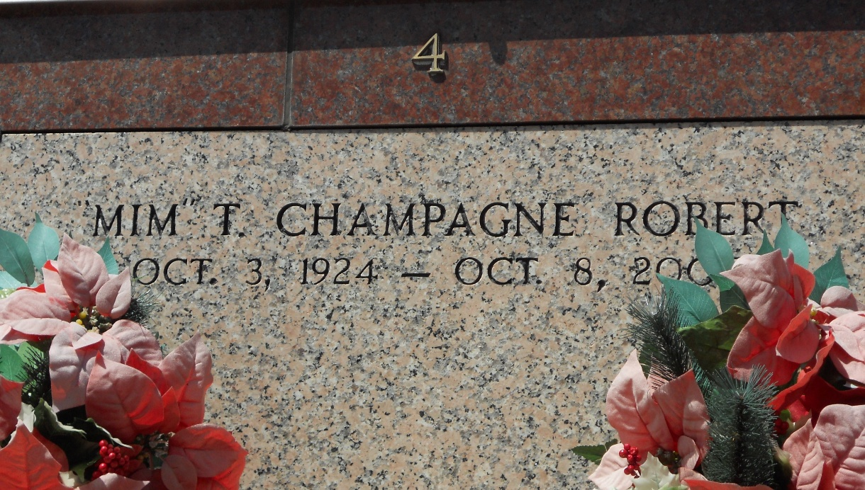

Mariam "Mim" Troxclair Champagne Robert, 76, a native and resident of Mt. Airy, died Oct. 8.
She was the wife by first marriage of the late Irving P. Champagne and by second marriage of Hewitt "Jap" Robert, mother of Dianne "De" Bourgeois, Paula Ann Heltz, Paul and Larry "Specks" Champagne and stepmother of Loretta Webre and Pat, Lida and Willie Robert. She was also the daughter of the late Marcel and Josepha Troxclair and sister of Adlice Waguespack, Bessie Poche and Sherman and Davis Troxclair. She is also survived by 16 grandchildren and six great-grandchildren.
Services were Oct. 13 at St. Hubert Catholic Church, Garyville, with interment at St. Peter Cemetery, Reserve.
L'Observateur, LaPlace, Louisiana
October 14, 2000

