Beverly Ann (Clement) Robertson
November 25, 1936 – July 5, 2003

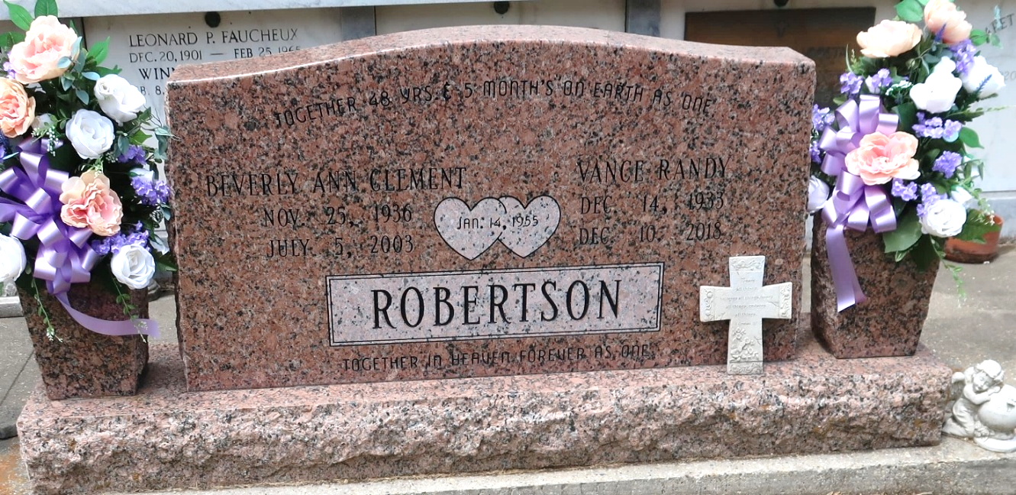

Beverly Clement Robertson On Saturday, July 5, 2003 At 6:30 Pm.
Beloved Wife Of Vance R. Robertson For 48 1/2 Years. Mother And Mother-In-Law Of Kirk And Linda, Kevin And Vanessa, Kearney And The Late Sandra, Kenny 'Michael' And Angie Robertson And The Late Kelly And Her Twin Sister.
Daughter Of The Late Emelien And Sylvania Boudreaux Clement. Sister Of Leah C. Warner And The Late Jeanne Bigelow And E.J. Clement Jr. Grandmother Of Randy Damian, Kira Reisha, Heathe, Austin Robertson And Kristy R. Jones. Great-Grandmother Of Destiny Messina And The Late Brett Robertson. Age 66 Years. A Native And Resident Of Reserve, Louisiana.
Relatives And Friends Of The Family Are Invited To Attend Services. Visitation At St. Peter Catholic Church In Reserve, La. On Tuesday, July 8, 2003 From 9:00 Am Until 11:00 Am. Followed By A Religious Service At The Above Named Church At 11:00 Am. Interment: St. Peter Cemetery, Reserve, La. Arrangements By Millet Guidry Funeral Home, 2806 W. Airline Hwy., Laplace, La.
Times Picayune, New Orleans, Louisiana
July 07, 2003

