Kirt Paul Robertson
August 9, 1955 – November 2, 2022

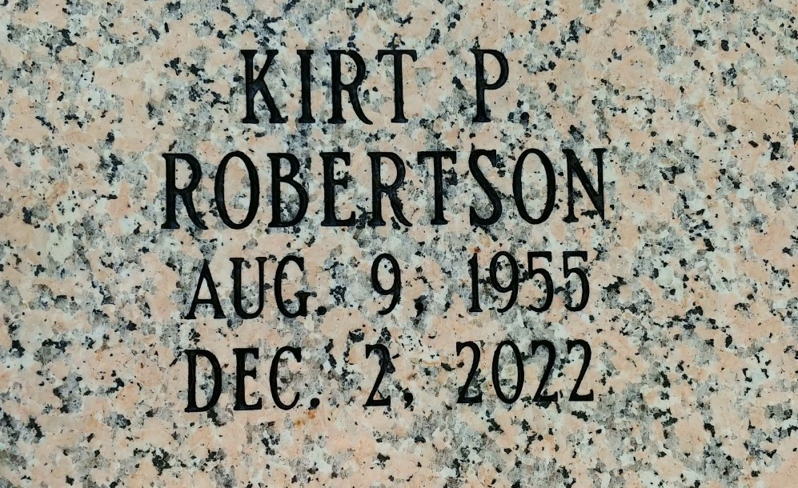
Photo by Team T-Lo

Kirt Paul Robertson passed away on Friday, December 2, 2022. He was 67, was born in New Orleans, LA and was a resident of Reserve, LA.
Beloved father of Kira Robertson (fiancé, Richard Stipelcovich, Jr.). Grandfather of Destiny Messina, Chance Blank, Jr. and Cameron, Tristan and Decklan Stipelcovich. Great-grandfather of Bently Clark. Son of the late Beverly Clement Robertson and Vance "Randy" Robertson. Brother of Kevin Robertson (Vanessa), Kearney Robertson (Kathy) and Kenny "Mike" Robertson (Angie) and the late twins Kelly and Karen Robertson. Brother-in-law of the late Sandra Robertson. Also survived by many nieces and nephews.
Relatives and friends are invited to attend the Visitation and Memorial Service at Rose Lynn Funeral Home, 1870 Cabanose Ave., Lutcher, LA on Friday, December 9, 2022. Visitation from 9:00 a.m. to 11:00 a.m. followed by a Memorial Service at 11:00 a.m. Interment in St. Peter Cemetery.

Rose Lynn Funeral Home, Lutcher, Louisiana

