Vance ‘Randy’ Robertson
December 14, 1933 – December 10, 2018

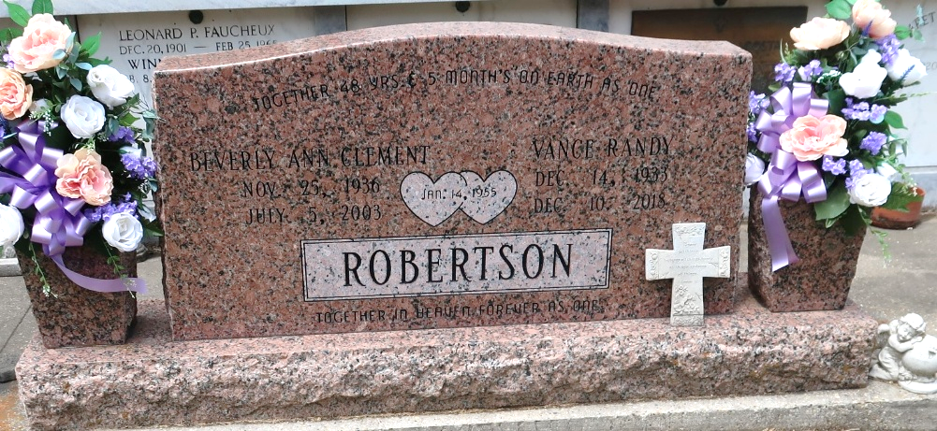

Vance “Randy” Robertson passed away peacefully surrounded by his loving family on Monday, December 10, 2018 at the age of 84. He was a native of Hammond, LA and a longtime resident of Reserve, LA and the last 12 years of Metairie, LA.
He was a Korean War Veteran and was a retired employee of Turner Industries. Vance was a member of the Plumbers and Steamfitters Local 60 for 52 years and a member of the American Legion Post 0401.
Beloved husband of Patricia Keir Robertson and former husband of the late Beverly Clement Robertson. Loving father of Kirt, Kevin (Vanessa), Kearney (Kathy and the late Sandra L. Robertson) and Kenny “Mike” (Angie) Robertson. Stepfather to Cheryl S. Hebert (Kevin), Lisa S. Elsensohn (Doug) and Edwin Sternberger (Eugene). Grandfather of Randy (Kellie), Kristy R. Jones (Bruce), Damian, Kira, Reisha, Heathe and Austin. Step-grandfather to James and Kelsey Hebert, Ashley, Matthew and Mylie Elsensohn and Edalie Sternberger and Casey and Kyler Smith, Clint & Brandon Breaud and the late Terilyn B. Poche, Caitlin Waldrop, Amanda & Cole Owen and several great-grandchildren whom he adored. Brother of Donald L. Robertson (Paula) and the late MG “Kenny” Robertson and William “Billy” Black. Brother-in-law of William A. Keir, III (Linda) and Robert J. Keir, Sr. Also survived by many nieces and nephews. Son of the late L.M. “Doc” Robertson and Reta Daniels and Edgar Denahm.
The family would like to extend a special thanks to the staff of Interim Health Care Hospice of Covington, LA, particularly Nurse Nicki and Nurse Todd for the special care that they gave for our loved one. He will be missed by his very special friend and neighbor, Maria D. Luce, and all who knew him.
Relatives and friends are invited to attend the Visitation at St. Peter Catholic Church, 1550 Hwy 44, Reserve on Saturday, December 15, 2018 from 9:00 a.m. to 12:00 p.m. followed by a Funeral Mass at 12:00 p.m. Interment in St. Peter Cemetery. Arrangements by Millet-Guidry Funeral Home.

Millet-Guidry Funeral Home, LaPlace, Louisiana
December 13, 2018

