Joseph Leo Robichaux Sr.
October 20, 1911 – May 4, 2004

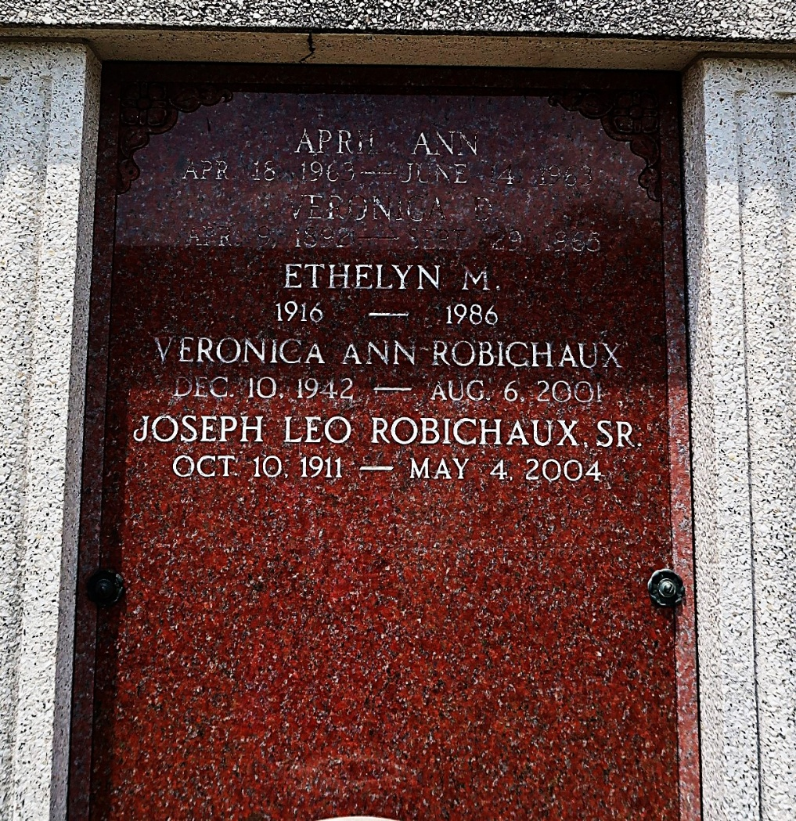

Joseph Leo Robichaux, Sr. On Tuesday, May 4, 2004 At 12:20 A.M.

Beloved Husband Of The Late Ethelyn Madere Robichaux. Father And Father-In-Law Of Robert (Bobby) And Myrtle, J.L., Jr. And Peggy, Lynn And Kathy Robichaux, Peggy R. And Johnny Mckinney, And The Late Veronica R. And Patrick Breaux. Son Of The Late Arthur And Veronique Donaldson Robichaux. Brother Of Mae R. Delaune And The Late Arthur And Albert Robichaux And Louise R. Richard.

Times Picayune, New Orleans, Louisiana
May 5, 2004

