Kathy Elaine (Wilson) Robichaux
August 25, 1943 – October 16, 2015

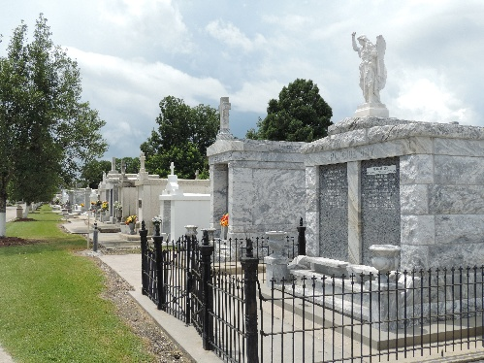

Kathy Elaine Wilson Robichaux passed away on Friday, October 16, 2015 in River Ridge, LA. Longtime resident of LaPlace, age 72.
Beloved wife of 54 years of Lynn Robichaux. Loving mother of Dawn Bardwell (Roddie), Denice Bailey (Danny), Lynn Robichaux, Jr. (Diane) and Jamie Robichaux. Devoted grandmother of April, Amber, Daniel, Ashley, Kayla, Brooke, Brandon and Brianne, and great grandmother of Reanna and Mia. Loving sister of Barry Wilson, Keller Wilson (Tal) and Ranney Wilson(Karen). Devoted aunt to many nieces and nephews. She is preceded in death by her parents, James and Carmen Wilson, her stepfather, Mark Anthony Klibert, and two daughters, April Robichaux and Kristin Robichaux. Kathy was dearly loved and will be greatly missed.
Relatives and friends are invited to attend the Visitation at Millet- Guidry Funeral Home, 2806 W. Airline Hwy., LaPlace, LA, on Monday, October 19, 2015 from 5:00 PM to 8:00 PM. The Funeral Mass will be held at St. Joan of Arc Catholic Church, 529 W. 5th St., LaPlace, LA on Tuesday, October 20, 2015 at 11:00 AM with Visitation at the church beginning at 10:00 AM. Interment to follow at St. Peter Cemetery. To view and sign the online guest book, please visit www.milletguidry.com
Times Picayune, New Orleans, Louisiana
October 17-21, 2015

