Kristin L. Robichaux
June 8, 1982 – July 7, 2008

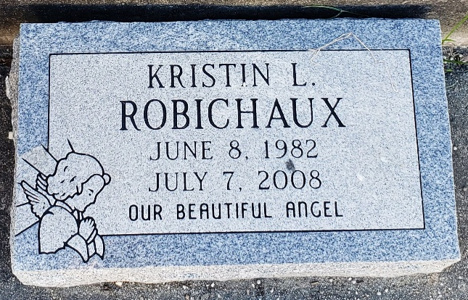

Kristin Robichaux is now peacefully embraced in the arms of our Heavenly Father. She went to her eternal rest on Monday, July 7, 2008 at 5:50PM.
Beloved daughter of Lynn and Kathy Wilson Robichaux. Sister of Dawn Bardwell and husband Roddie, Denice Bailey and husband Daniel, Lynn Robichaux and wife Diane, Jamie Robichaux and the late April Robichaux. Beloved Granddaughter of Carmen Wilson and the late James Wilson. Step-granddaughter of Mark Klibert. Granddaughter of the late Joseph, Sr. and Ethelyn Robichaux. Long-time friend and companion of Mark Klibert, Jr. Special aunt of April and Amber Labat, Daniel, Ashley and Kayla Bailey, Brooke, Brandon and Brianne Robichaux. Great-aunt of Reanna and Mia. Also survived by numerous aunts, uncles and cousins.
She graduated from S.L.U. Magnum Cum Laude, Bachelor of Science degree and was pursuing higher education. She touched many lives working with the handicapped and disabled. She will be sadly missed by her dog Bandit. Age 26. A native and resident of LaPlace.
Relatives and friends are invited to attend services. Visitation at Millet-Guidry Funeral Home, 2806 W. Airline Hwy., LaPlace, La., on Thursday, July 10, 2008 from 5PM to 9PM and on Friday from 9AM to 11:30AM. Followed by Religious Services at St. Joan of Arc Catholic Church, LaPlace, La. at 12 Noon. Burial in St. Peter Cemetery Reserve, LA.
Times Picayune, New Orleans, Louisiana
July 9, 2008

