Lanard Joseph Robinet
August 21, 1936 – January 22, 2012

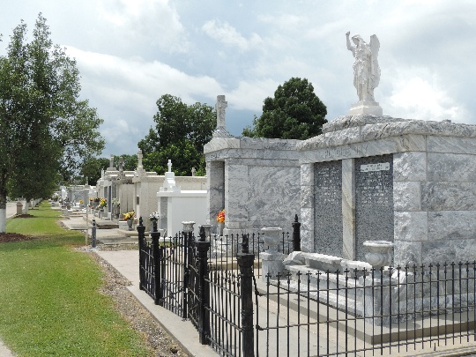

Lanard Joseph Robinet on Sunday, January 22, 2012 at his home in LaPlace, LA. Son of the late Thelma Booker and Theophile L. Robinet. Beloved husband of Murle Robinet of 51 years.
Father of Antionette Robinet and Monica Robinet Joseph (Felix, III) of LaPlace, LA, Bernadette Robinet Pickett (Juan) of Houma, LA, Medria Robinet Gauff (Errol) of Hammond, LA and Jacinta Robinet Bell (David) of Luling, LA. Brother of McLouis Robinet (Harriette) of Oak Park, IL Grandfather of Felix C. Joseph, IV, Jessica Whitney Pickett, Hailey Elizabeth Gauff and David "Jake" Bell. Also survived by a host of brothers and sisters in law, nieces, nephews, other relatives and friends. Age 75 years. A native of Reserve, LA and resident of LaPlace, LA.
Relatives and friends of the family also priests and parishioners of St Joan of Arc Catholic Church and all neighboring churches, members of Knights of Columbus #5935 and employees of St John Parish Sheriff Department and St John Parish School Board are invited to attend the Mass of Christian Burial at St Joan of Arc Catholic Church, 529 West 5th Street, LaPlace, LA on Saturday, January 28, 2012 at 12:30 PM. Fr. John Tran, Celebrant. Interment St Peter Cemetery, Reserve, LA. Visitation at the above named church from 10:30 AM until Mass Time. SERVICED BY ROBOTTOM
Times Picayune, New Orleans, Louisiana
January 25-27, 2012

