David E. Robinson Sr.
December 17, 1936 – October 20, 2002

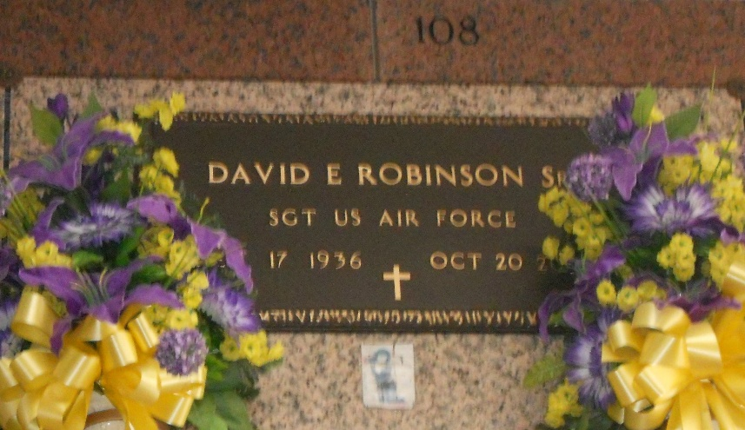
Photo by Team T-Lo

David (Crockett) (Sarge) Robinson, Sr. of Reserve, LA. on Sunday October 20, 2002 at River Parishes Hospital, LaPlace, LA.
Husband of Shirley Cook Robinson. Son of the late Jessie and Beethal Robinson. Father of David Jr., Karen Jones, Marcel Wallace, Yvette Robinson and Uneika Henderson. Brother of James, Ray, Jessie Robinson, Jr., Doris, Brenda Robinson, Marcel Hodges and the late Mae Sanders, Eula Robinson. Father-in-law of Ursula A. Robinson, Todd Wallace, Brandon Henderson and Lawrence Jones. Also survived by 6 grandchildren, a host of nieces, nephews, sisters and brothers-in-law, 1 godchild Kevin Bovie, Cousins, other relatives and friends. A native of New Orleans and a resident of Reserve, LA for the past 42 years, age 65 years.
Relatives and friends of the family, also pastor, officers and members of Bethlehem B.C., Beech Grove, B.C., Lutcher Chapel United Methodist, St. Mark B.C. and neighboring churches. Former employees of Godchaux-Henderson Sugars, employees of Colonial Sugars, River Parishes Hospital, Onyx of Gonzales, Lafourche Parish School System, Chateau Living Center, and St. Peter Catholic Church Rectory are invited to attend the funeral services on Saturday October 26, 2002 at 11:00 A.M. from the Bethlehem B.C., Reserve, LA. Rev. Forell Bering officiating. Interment St. Peter Catholic Church Cemetery, Reserve, LA. Visitation at the church after 9:00 AM on Saturday. THE BALONEY FUNERAL HOME in charge of arrangements.
Times Picayune, New Orleans, Louisiana
October 25, 2002

